ASSESSMENT OF THE STONE QUARRYING ACTIVITIES ON SUSTAINABLE ENVIRONMENTAL MANAGEMENT IN KAJIADO EAST SUB COUNTY, KAJIADO COUNTY, KENYA

KARANI S MWORIA

A Thesis Submitted In Partial Fulfilment Of The Requirements For The Award Of The Degree Of Master Of Science In Environment And Natural Resources Management In The Department Of Environment And Natural Resources Management Of Africa Nazarene University-

June 2025

DECLARATION
I declare that this thesis proposal is my original work and has not been presented for a degree in any other University.

KARANI S MWORIA
(19J01DMEV008 )
This thesis report is submitted for examination with our approval as university supervisors to the student
______________________ Date …25/06/2025………….
Dr. David Mugendi
Department of Environment and Natural Resource Management
AFRICA NAZARENE UNIVERSITY
NAIROBI, KENYA

____________________ Date…25th June, 2025…..
Dr. Sharon Jones
Department of Environment and Natural Resource Management
AFRICA NAZARENE UNIVERSITY
NAIROBI, KENYA

EXAMINERS’ SIGNATURES
We have examined this document and the research has met or exceeded the requirement for the degree sought, in addition, the candidate has sufficiently defended the material presented to merit the awarding of the degree of Master of Science in Environment and Natural Resources Management

__________________________ __20th June, 2025_________
Internal examiner signature Date

Dr Micky Mwamuye
Internal examiner

________________ ___17th June, 2025_________

External examiner signature Date
Dr Christine Majale
Notes: (Pass, Pass with Distinction)

DEDICATION
I dedicate this work to my wife Emily Mworia who encouraged and supported me throughout my studies. I also dedicate it to my children, who were supportive and very patient during this study period. Thank you so much and may the Almighty God bless you all.

ACKNOWLEDGEMENT
First and most importantly, I thank Almighty God for giving me the strength and good health to write this research proposal. I would like to express my gratitude to my family, who have been supportive, understanding, and cooperative throughout this research period. My appreciation goes to my supervisors, Dr. David Mugendi and Dr. Sharon Jones, for their guidance, reviews, and advice, which are shaping up to be a document with a good, intended outcome. I thank them for their time and corrections, which enabled me to meet the required academic standards. May God Bles you all.

TABLE OF CONTENTS
DECLARATION ii
EXAMINERS’ SIGNATURES iii
DEDICATION iv
ACKNOWLEDGEMENT v
TABLE OF CONTENTS vi
LIST OF TABLES x
LIST OF FIGURES xi
ABSTRAC xii
DEFINITIONS OF TERMS xiii
ABBREVIATIONS AND ACRONYMS xiv
CHAPTER ONE 1
INTRODUCTION AND BACKGROUND 1
1.1 Introduction 1
1.2 Background of study 1
1.3 Statement of the problem 4
1.4 Purpose of the Study 5
1.5 The objectives of the study 5
1.6 Research questions. 5
1.7 Hypothesis of the Study 6
1.8 Significance of the Study 6
1.9 Scope of the Study 6
1.10 Limitations of the proposed study 7
1.11 Assumptions 8
1.12 Theoretical framework 8
1.12.1 System theory 9
1.12.2 Sustainable livelihood theory 10
1.13. Conceptual Framework 10
CHAPTER TWO 12
LITERATURE REVIEW 12
2.1 Introduction 12
2.2 Empirical Review 12
2.2.1 Quarrying activities on the biophysical environment 12
2.2.2 Quarrying activities effects on socio-economic characteristics/aspects 14
2.2.3 Legal, Policy and Institutional Framework Governing Quarry Industry 15
2.3 Research Gap 17
CHAPTER THREE 19
RESEARCH METHODOLOGY 19
3.1 Introduction 19
3.2 Research design 19
3.3. Research site 20
3.4 Target population 21
3.5 Study Sample 22
3.5.1 Sampling Procedure 22
3.5.2. Sample Size 23
3.6 Data collection instruments 24
3.6.1 Data Collection on Assessment of the Impacts of Stone Quarrying Activities on the Biophysical Environment 24
3.6.2 Data Collection to Investigate the Effects of Stone Quarrying Activities on Socio-Economic Characteristics of the Local Communities 25
3.6.3 Data Collection to Appraise the Current Policy, Legal, and Institutional Framework Governing Management and Control of Stone Quarrying Activities 25
3.7 Piloting Testing 27
3.8 Reliability 27
3.9 Validity 28
3.10 Data processing and analysis 28
3.10.1 To Assess the Impacts of Stone Quarrying Activities on the Biophysical Environment 28
3.10.2 To Investigate the Effects of Quarrying Activities on Socio-Economic Characteristics of Local Communities 29
3.10.3 To Appraise the Current Policy, Legal, and Institutional Framework Governing Management and Control of Stone Quarrying Activities 30
3.11 Legal and Ethical Considerations 31
CHAPTER FOUR 32
DATA ANALYSIS AND FINDINGS 32
4.1. Introduction 32
4.2. Response Rate of Data Collection Instruments 32
4.3. Demographic Characteristics of the Participants 32
4.4. Findings For Objective One: Impacts of Stone Quarrying Activities on the Biophysical Environment 35
4.5. Findings For Objective Two: Socio - Economic Environment and Sustainable Environmental Management 40
4.6. Findings For Objective Three: Policy, Legal, and Institutional Framework and Sustainable Environmental Management 45
4.7. Inferential statistics 48
4.7.1. Correlational analysis between stone quarrying activities and NDVI of vegetation cover 48
4.7.2. Regression analysis between stone quarrying activities and NDVI of vegetation cover 49
4.7.3. Regression analysis between the local’s income and quarrying activities in the study area 53
CHAPTER FIVE 69
DISCUSSIONS, CONCLUSIONS AND RECOMMENDATIONS 69
5.1 Introduction 69
5.2. Discussions 69
5.2.1. Stone Quarrying Activities and Sustainable Environmental Management 69
5.2.2. Socio-Economic Environment and Sustainable Environmental Management 73
5.2.3. Policy, Legal, and Institutional Framework and Sustainable Environmental Management 74
5.2.4. Proposed Sustainable Quarry Management Model for Kajiado East Sub-County 77
5.3. Summary of the findings 78
5.3.1. Stone Quarrying Activities and Sustainable Environmental Management 78
5.3.2. Socio-Economic Environment and Sustainable Environmental Management 79
5.3.3. Policy, Legal, and Institutional Framework and Sustainable Environmental Management 79
5.4. Conclusions 80
5.5. Recommendations from the Findings 81
5.6 Suggestions for Further Study 82
REFERENCE 84
APPENDICES 89
Appendix 1: Questionnaire for respondents 89
Appendix II: Letter from Institution 94
Appendix III: NACOSTI License 95
Appendix III: Map of the area of study. 96

LIST OF TABLES
Table 3.1: Target Population 22
Table 3.2: sample size 24
Table 3.3: Summary of Research Objectives and Corresponding Target Information for Data Collection 26
Table 3.3: Reliability Statistics 28
Table 4.1: Response rate 32
Table 4.2: Gender of participants 33
Table 4.3: Age of participants 33
Table 4.4: Occupation of the participants 34
Table 4.5: Residential status 34
Table 4.6: Stone Quarrying Activities and Sustainable Environmental Management 35
Table 4.7: Socio - Economic Environment and Sustainable Environmental Management 40
Table 4.8: Policy, Legal, and Institutional Framework and Sustainable Environmental Management 45
Table 4.9: Correlational analysis between stone quarrying activities and NDVI of vegetation cover 48
Table 4.10: Model Summary^{b} 49
Table 4.11: ANOVAª 50
Table 4.12: Coefficientsª 51
Table 4.13: Chi-Square Tests 51

LIST OF FIGURES
Figure 1.1. Conceptual model for sustainable quarrying activities for Kajiado, source: Author, 2024) 11
Figure 3.1: Map of Kajiado County 21
Figure 4.1: Normal P–P Plot of Regression Standardized Residuals for the Dependent Variable "Impacts on the Socio-Economic Environment 56
Figure 4.2: Land Use Land Cover (LULC) Map for the Year 1993. 59
Figure 4.3: Land Use/Land Cover (LULC) map of the study area in 2003, 60
Figure 4.4: Land Use/Land Cover (LULC) map of the study area in 2013 61
Figure 4.5: Land Use/Land Cover (LULC) map of the study area in 2023 61
Figure 4.6: Sankey Diagram 65
Figure 4.7: Land Degradation Status in Sholinke Ward, Kajiado County 67

ABSTRACT
Stone quarrying has remained a vital economic activity, providing essential raw materials for infrastructure development. However, its environmental and socio-economic implications have raised growing concerns, especially in developing countries. Quarrying activities have had both positive and negative effects on the biophysical environment and the livelihoods of nearby communities. While the industry created employment opportunities, improved local incomes, and contributed to infrastructure development, it also resulted in significant environmental degradation, including loss of biodiversity, dust and water pollution, lowering of the water table, soil erosion, land deformation, and increased health risks such as respiratory ailments and accidents. In Kenya, the rapid expansion of quarrying operations, driven by the high demand for building materials, intensified these challenges. Although several studies have examined the impacts on air and water quality in Kajiado County, few have comprehensively assessed the changes in vegetation cover and socio-economic effects in pastoral regions, such as Kajiado East Sub-County. This gap highlighted the need for a detailed investigation into the relationship between quarrying operations, environmental outcomes, and community welfare. The purpose of this study was to assess the effects of quarrying activities on the biophysical environment and socio-economic well-being of communities in Kajiado East Sub-County, and to propose sustainable management approaches. Specifically, the study sought to assess the impacts of stone quarrying on the biophysical environment, investigate its effects on local employment and livelihoods, appraise the existing policy, legal, and institutional frameworks governing quarrying operations, and develop a sustainable quarry management model applicable to Kajiado County and Kenya. A mixed-methods research design was employed, integrating a case study, descriptive survey, and cross-sectional analysis. Data were collected through stratified and simple random sampling of 500 respondents using questionnaires, semi-structured interviews, focus group discussions, direct field observations, and analysis of Landsat and Sentinel satellite imagery spanning 1993 to 2023. Land-use and land-cover changes were analyzed using ArcGIS, while SPSS 29 facilitated statistical analysis. The study revealed that quarrying significantly contributed to land degradation, reduced vegetation cover, altered topography, and polluted both surface and groundwater resources. Socio-economically, quarrying improved employment opportunities and household incomes but also displaced communities, reduced agricultural land, triggered conflicts, and increased health hazards. Chi-square tests confirmed significant associations between quarrying intensity and both environmental quality and socio-economic welfare. Respondents identified weak regulatory enforcement, poor inter-agency coordination, and political interference as significant obstacles to effective quarry management. The study recommended strengthening environmental enforcement units, integrating phased land rehabilitation into quarry licensing, establishing community benefit-sharing frameworks, and promoting multi-stakeholder quarry management committees to achieve balanced and sustainable development.

DEFINITIONS OF TERMS
Landscape is the assemblage of objects that make up a particular part of the earth's surface.
Quarrying: it is defined briefly as the extraction of surface minerals and their processing for the market.

ABBREVIATIONS AND ACRONYMS
ASAL | Arid and Semi-Arid Lands
ANU | Africa Nazarene University
BFAST | Breaks-for-Additive-Seasonal-Trend
CIDP | County Integrated Development Plan
EAP | Environment Action Plan
EIA | Environmental Impact Assessment
EMCA | Environmental Management and Coordination Act
GOES | Geostationary Operational Environmental Satellite
GIS | Geographic Information System
GEE | Google Earth Engine
USGS | U.S. Geological Survey
KNBS | Kenya National Bureau of Statistics
LULC | Land Use and Land Cover
MNMR | Ministry of Mining and Maritime Affairs
NEMA | National Environment Management Authority
NACOSTI | National Council of Science, Technology and Innovation
NDVI | Normalized Difference Vegetation Index
NIR | Near-Infrared
SPSS | Statistical Package for the Social Sciences
SOC | Soil Organic Carbon
UNCCD | United Nations Convention to Combat Desertification

CHAPTER ONE

INTRODUCTION AND BACKGROUND

1.1 Introduction
This chapter provides a comprehensive overview of the study by presenting the background and context that underpin the research. It articulates the problem statement, highlighting the specific issues that the study seeks to address. The purpose and objectives of the study are clearly outlined to guide the research process, along with the key research questions that the study aims to address. Furthermore, the chapter discusses the significance of the study, emphasizing its potential contributions to knowledge, practice, and policy. It also delineates the scope, limitations, and delimitations to define the boundaries within which the study is conducted. Additionally, the chapter outlines the underlying assumptions that inform the research and presents the theoretical and conceptual frameworks that provide a foundation for analyzing and interpreting the study’s findings.

1.2 Background of study
Quarrying is a global activity that involves the pull out of different types of natural earth materials from the ground for use in various industries. Quarrying takes place in a quarry, which is an area that has resources such as marble, limestone, sand, and granite for industrial use, (Spurn, 2013). This activity is carried out by both large- and small-scale entities all over the world, where numerous quarries are located near urban centres for the ease of transporting raw materials into cities for use in various other industries. This proximity subjects the inhabitants to air pollution from dust and noise generated by trucks and machinery, which destroys what may have once been a delightful landscape. The main consumers of stone mining and quarrying activities are the infrastructure and building industries, which consume these products in the form of sized slabs or blocks, natural or crushed particles, and processed products like cement and lime (Ballesteros et al., 2014). Quarrying may have a negative impact on the community and the environment at large, but it is the backbone of industrial civilization, as materials retrieved are used to create homes and transport structures with cement, concrete, crushed stones as well as other industrial raw materials such as abrasives, binders, additives, and roofing. It’s also a source of sustenance for many people worldwide since they are employed in menial jobs. (McCandless 2013).
Humans have used stone for building castles, walls, churches, and other important structures for many years due to its durability and weather resistance. Quarrying for building stones emerged due to their high demand, driven by their durability and block sizes, which made them a preferred choice in building and construction. However, this preference has a negative impact on environmental sustainability. Development requires the efficient utilisation of available resources and an understanding of their effects on extraction within the environment. However, quarrying faces several limitations, including a lack of basic knowledge of safety precautions, poor working conditions, a low socioeconomic status, unclear quarrying legislation, and environmental degradation. In South Sudan, several stone quarries have been established due to the great demand for stones for road construction and building purposes (Moilinga & Athian, 2023).
According to Turyahabwe et al. (2021). Stone quarrying is an economic activity that has led to rapid development in the building and infrastructure sectors due to increased demand for rock-based construction materials. It has subsequently increased the availability of construction materials, such as stone aggregates, stone dust, cement, and building lime, and improved living standards due to increased incomes and employment opportunities for the local population. However, quarrying distorts nature by disturbing unique habitats, significantly altering topography, and unchecked disruption of basic ecological relations.
Quarrying in Kenya is a widespread activity, with stone quarries existing in almost all counties in the country. It has proven to be a major source of livelihood. It has proven to be a major source of livelihood, despite the dangers it poses to the environment. The primary driver is the demand for materials for buildings and infrastructure, such as stone blocks, sand, ballast, and hardcore. Raw materials include pozzolana, limestone, iron ore, and gypsum, which are used in the manufacture of cement and lime. (Wangela, 2019).
The demand for building materials in Kenya is overwhelming, particularly in urban centres, where the need for structures to accommodate diverse human activities is consistently present. The major components of building construction are mainly stones, cement sand, and concrete which are materials sourced from within the earth’s upper crust. The extraction of such materials involves the process of quarrying. Quarrying may also be carried out in search of other natural minerals and valuable resources for manufacturing or other industries (Onyango et al 2016). While quarrying activities are of great importance for socio-economic development, they have significant implications for sustainable environmental management unless they are well managed.
Many families earn their livelihoods from the quarry industry, including leasing land, quarrying, providing skilled and manual labour, and offering services such as transportation (Makau, 2021). Quarrying tends to be more common in areas where the land is poor and is unable to support crops. The owners of such land, therefore, find it more profitable to lease it out for quarrying. While stone mining and quarrying is a welcome economic activity for many people, it also has numerous negative impacts, including soil erosion, air pollution, reduction of ground cover, land degradation, destruction of forests and arable lands, and loss of habitat for some animals and plant species. It is, therefore imperative to assess the effects of quarrying to ensure it is carried out in a sustainable manner, guaranteeing maximum socio-economic benefits with minimal negative impact on vegetation cover.
Kajiado East sub-county's topography is punctuated with dozens of quarries in Sholinke and Nkurunga villages, covered with heavy dust spiralling up as large trucks transport stones to be used as building materials and raw materials for cement manufacturing. (Ngotho, 2023). Quarrying of building stones is carried out in the entire subcounty. The major areas are Ngong, Kitengela and Ongata Rongai. The high demand for building materials is driven by the migration of people from Nairobi to emerging towns. (NEMA 2013). According to Mbandi (2017) quarries that have been abandoned without rehabilitation poses environmental challenges. Stone quarrying in Kajiado East sub-county, especially in Kitengela, has resulted in the inception of quarries that have been left abandoned without restoration as miners move to new establishments.

1.3 Statement of the problem
Quarrying activities have several impacts on the biophysical environment and the socioeconomic status of the people surrounding the quarrying sites (Lad & Samant, 2014). The quarrying impacts have both positive and negative effects on the vegetation cover and social economic status of the community. The environment is negatively impacted by the loss of biodiversity, dust pollution, water pollution, lowering the water table, insightful scars, and noise pollution. When left open, the quarry pits develop into death traps for livestock and humans, as well as becoming homes to water-borne disease vectors (Kaliampakos & Mavrikos, 2006).
Quarrying activities reduce vegetation cover, leading to soil erosion, which in turn results in less grazing and farmland, ultimately leading to lower agricultural activities. The primary purpose of quarrying is its positive impact on the community, including the creation of menial jobs, a source of income, and improved infrastructure (Chigonda, 2010). However, quarrying has a negative impact on people due to increased air and dust pollution, causing pneumonia, eye, and ear infections, as well as other respiratory diseases. Open pits are a precursor to accidents and water source pollution that can result in waterborne diseases (Lad & Samant, 2014).
Several studies have been conducted on quarrying activities in Kajiado County; however, few academic studies have been done in the Kajiado East sub-county. Some studies have investigated the impact of quarrying on water and air, but a few studies have assessed vegetation cover and its impacts on the environment, more so in pastoral areas, hence the need for this study. Moreover, the study is necessary to investigate the interrelationships between the operations and the outcomes, including the inherent hazards and effects on both the physical and social environments. The huge demand for building materials results in the increase in the opening of new quarries and increased quarrying activities. The various government institutions involved in the licensing and regulation of quarrying activities must be vigilant to ensure smooth operations and sustainable environmental management (Makau, 2021).

1.4 Purpose of the Study
Quarrying activities have detrimental impacts on the biophysical environment despite their social and economic benefits. The current concern about global sustainable development suggests that the effects of quarrying activities outweigh their benefits and may require sustainable utilisation for the benefit of both the biophysical and socioeconomic environments. The impact of quarrying activities can form the basis of conflicts between quarrying firms and the communities around the quarrying area (Lad & Samant 2014). The study, therefore, assesses the effects of quarrying activities and proposes mitigation measures and approaches in environmental management. It also observes and comments on existing national and county legal policies that will determine the establishment and operation of quarries and quarrying activities for sustainable environmental management in Kajiado East Sub–location.

1.5 The objectives of the study
The general objective of this study was to assess the impacts of quarrying activities on the biophysical and socio-economic in Kajiado East sub county and develop a sustainable quarry management approach in Kajiado County and Kenya in general.
The specific objectives were:
- To assess impacts of stone quarrying activities on the biophysical environment Kajiado East Sub County.
- To investigate the effects of stone quarrying activities on the employment of local communities of the study area in the Kajiado East Sub County.
- To appraise the current policy, legal and institutional framework governing the management of stone quarrying activities in Kajiado East Sub County.

1.6 Research questions.
The study is guided by the following research questions.
- What are the impacts of quarrying activities on the biophysical environment in Kajiado East sub-county?
- What are the impacts of quarrying activities on the socio-economic aspects of the local communities Kajiado East sub-county?
- What are the existing policies and legal and institutional framework governing quarrying activities in Kajiado East Sub County and in Kenya?

1.7 Hypothesis of the Study
The study adopted the following hypothesis.
- H₀ - There is no significant relationship between stone quarrying activities and NDVI of vegetation cover in the study area.
- H₀-There is no significant relationship between the local’s income and quarrying activities in the study area.

1.8 Significance of the Study
This study holds significance for several stakeholders. For policy makers and county governments, it highlights regulatory gaps and enforcement failures, offering evidence-based recommendations to strengthen legislation and institutional capacity for sustainable quarry management. For environmental institutions such as NEMA and the Ministry of Environment and Forestry, the findings provide actionable insights for revising policies and licensing protocols. Researchers and academia will benefit from empirical data that can inform further studies on the environmental and socio-economic impacts of quarrying. Quarry workers and landowners will gain knowledge on the implications of unsafe quarry practices and the need for structured agreements, while local communities will be empowered through awareness of their environmental rights and the long-term implications of unregulated quarrying. Overall, the study seeks to contribute to the development of a more sustainable, equitable, and environmentally conscious quarrying sector in Kajiado East Sub-County.

1.9 Scope of the Study
The study was conducted in Kajiado East Sub County of Kajiado County, Kenya. The study aimed to assess the impact of quarrying activities on biophysical environments and their socio-economic effects on the community in relation to established guidelines and standards in active quarry fields. Stone quarrying activities have negative environmental effects, including land disturbance, ground vibration, loss of biodiversity, dust emission, and noise pollution. Stone quarrying is an operation that involves the removal of large blocks of stone and other raw materials found underground with valuable qualities. During stone quarrying activities, workers and the community at and around quarry sites are exposed to and inhale dust that may cause respiratory diseases. (Wangela & Shah, 2021).
According to Turyahabwe et al. (2021), stone quarrying contributes to economic growth through the rapid development of infrastructure using rock-based construction materials. Both genders engage in quarrying activities directly earning wages and income proceeds through the sale of stone quarrying products, which include stone aggregates, stone dust, cement, and building lime. Additionally, stone quarrying activities contribute to economic growth. As an economic activity, it is associated with an increased tax base for the government and better standards of living due to increased incomes and casual employment opportunities for the local population. However, some types of occupations, such as stone quarrying, can degrade the biophysical environment, causing undesirable environmental outcomes, including soil erosion and loss of rich biodiversity, particularly when opening new quarry sites as well as around abandoned quarry sites (Turyahabwe et al., 2021).
Sustainable management approaches for environmental sustainability were assessed and recommended for areas that have undergone quarrying compared to virgin fields. A lot of concern was on what major factors stimulate and contribute, as well as useful information on various aspects of the environmental effects that result from quarrying activities. Multiplication and proximity of quarry fields, socio-economic activities, and community social status are some of the factors that were sampled. The study also examines environmental policies, laws, and regulations, as well as the current management practices governing the operation of quarrying activities. The study ran for three months, from March 1st to May 30th, 2025.

1.10 Limitations of the proposed study
Several limitations were encountered during the study, which had the potential to hinder the achievement of the intended objectives. Many quarries in Kajiado Sub County are located in remote areas that require significant time and specific means of mobility to access. To address this, the study strategically confined its scope to a purposive sample of both active and abandoned quarries that were practically accessible within the available resources and timeframe. Additionally, poor infrastructure in parts of Enguranga Sub County posed logistical challenges. This was mitigated through prior planning, engaging local guides familiar with the terrain, and scheduling visits during dry weather when roads were more navigable. A further limitation emerged from the social and economic significance of quarrying in Kajiado East. The area's rocky topography renders it unsuitable for arable farming, making quarrying a primary livelihood source. As a result, many respondents were hesitant to discuss the disadvantages of quarrying, fearing potential economic repercussions. To overcome this, the researcher employed rapport-building strategies, guaranteed respondent confidentiality, and used indirect questioning techniques to elicit honest responses without causing discomfort. Despite these challenges, the study maintained empirical rigor and a systematic approach in data collection and analysis, ensuring the findings remained credible and representative of the study context.

1.11 Assumptions
This study made several assumptions. First, quarrying is rampant, and it is a major source of livelihood in Kajiado East Sub County. Secondly, quarrying excavations have disrupted the biophysical environment by destroying vegetation. Thirdly, most of the land in Kajiado East Sub County is suitable for quarrying due to the availability of underground stone, a raw material for stone building and ballast. Fourthly, quarrying activities do not significantly impact the biophysical environment; instead, they support social and economic activities. Lastly, all available resources, including respondents, will provide sufficient honest and relevant data to answer the research questions.

1.12 Theoretical framework
Focus has been placed on the negative effects of quarrying activities in the Kajiado East area of Kajiado County, due to the very apparent changes in the landscape and air quality pollution. However, very little attention has been given to the benefits to the local and national economy and the role played by existing laws and regulations in streamlining these activities for the mutual benefit of all stakeholders. As such there is a need to examine how the different activities affect each other and how to improve existing laws and regulations to streamline the quarrying operations.
According to Grant & Osanloo (2014), the theoretical framework serves as a blueprint, guiding the development and support of a given study. It is a pillar upon which basic ideas of what concepts and principles coalesce around during the study.

1.12.1 System theory
According to Laszlo and Krippner (2018), a system is a web of interacting components whose relationships allow for the identification of boundary-maintaining processes. This study applied Systems Theory, initially proposed by Ludwig von Bertalanffy, to examine the interconnectedness between quarrying activities and the surrounding ecological and socio-economic systems in Kajiado Sub County. Central to this approach was the tenet of interconnectedness, which views quarrying operations, land use changes, biodiversity, and community livelihoods as parts of a larger, interdependent system. The extraction of stones alters one part of the system, leading to cascading effects on vegetation cover, water resources, and food security. The study also employed the concept of an open system, recognizing that the environment interacts continuously with quarrying activities. Once sites are abandoned without rehabilitation, the system’s ability to self-regulate is compromised, leading to persistent ecological imbalances. Additionally, the principle of feedback mechanisms was integrated through the collection of community perceptions and responses, which reflect the system’s adaptive capacity and inform potential regulatory adjustments. Lastly, the study embraced holism, avoiding isolated analysis of quarrying impacts and instead examining how quarrying intersects with ecological health, economic activity, and social well-being. By applying these tenets, Systems Theory provided a coherent framework for understanding the complex, multi-dimensional effects of quarrying and guided the empirical design of the research, enabling a systematic exploration of problems, their causes, and possible interventions within an interconnected environmental and human system.

1.12.2 Sustainable livelihood theory
According to Wamari et al. (2016), Kajiado County is experiencing rapid land use changes driven by the subdivision of communal ranches and increasing population pressure, leading to a transition from pastoralism to agriculture, agro-pastoralism, and extractive industries such as quarrying. This study applied the Sustainable Livelihoods Approach (SLA) to assess how quarrying activities affect community welfare and resource sustainability in this evolving landscape. Central to this approach is the recognition of five core livelihood assets, natural, financial, human, physical, and social capital, all of which are influenced by quarrying operations. The study examined how quarrying depletes natural capital through land degradation and loss of vegetation, while at the same time providing financial capital as an alternative income source for local households. The tenet of vulnerability context was applied to assess how factors such as climate variability, drought, poor infrastructure, and resource scarcity exacerbate community vulnerability and shape livelihood choices. Additionally, the principle of livelihood strategies was reflected in the way households diversified income sources by combining livestock keeping, small-scale farming, and quarrying to sustain their livelihoods. The transforming structures and processes component was addressed by evaluating how local governance, land tenure systems, and environmental policies influence resource access, quarry site management, and household decision-making. Lastly, the study acknowledged the importance of sustainable livelihood outcomes, focusing on how quarrying impacts long-term welfare, food security, environmental integrity, and poverty alleviation. By integrating these tenets, the Sustainable Livelihoods Approach provided a practical, people-centered framework for exploring how communities in Kajiado East Sub County negotiate the competing demands of economic survival and environmental sustainability..

1.13. Conceptual Framework
The conceptual framework for this study was designed to examine the environmental and socio-economic impacts of quarrying activities in Kajiado East Sub County. It conceptualizes quarrying activities, including excavation, soil erosion, vegetation cover changes, disruption to infrastructure, and airborne diseases, as independent variables. These activities directly influence dependent variables such as land degradation, air pollution, reduced vegetation cover, disruption of ecological function, household income, and land ownership patterns. This framework guided variable selection, data collection, and analysis.

Dependent Variable
Land degradation
Air pollution
Degraded vegetation cover (NDVI changes)
Disruption of ecological function
Household income
Land ownership changes

Independent Variable
Excavation
Soil erosion
Vegetation cover changes
Airborne diseases
Disruption to social and physical infrastructure

Figure 1.1. Conceptual model for sustainable quarrying activities for Kajiado, source: Author, 2024)

CHAPTER TWO

LITERATURE REVIEW

2.1 Introduction
This chapter presents the relevant concepts and theories by highlighting the procedures of quarrying activities, their outcomes, and how they affect the biophysical environment and socio-economic activities in Kajiado East Sub County. It also seeks to highlight the gaps, opportunities, constraints, and limitations of the policies, laws, and legal framework available for minimising the effect of quarrying activities on the biophysical environment. The problem statement, objectives, and research questions will guide the structure of the literature review. The dependent variables in this study include excavation, soil erosion, vegetation cover changes, and social and physical infrastructures. The independent variables will be biophysical environments, NDVI, disruption of ecological function, income, and land ownership.

2.2 Empirical Review

2.2.1 Quarrying activities on the biophysical environment
Quarrying and mineral extraction in the United Kingdom is carried out on a wide geological and hydrogeological environment, from shallow excavation in unconsolidated deposits of sand to gravel to very deep and vertical-sided quarries to hard carboniferous and granite rocks. The deeper and more extensive the quarry, the greater the adverse impact on the biophysical environment. (Stuart & Davies 2002). In Nigeria, the most prevalent negative effect of quarrying minerals from the earth’s surface is the destruction of its natural landscape, creating open space in the ground and generating heaps of soil wastes, (Okafor 2006).
Quarrying and mining activities are destructive enterprises as they alter vegetation cover, (Mbandi, 2017). They destroy flora as well as natural resources, generating dusts particles that interfere with plant growth. Heavy machines interfere with ground alignment, causing a high level of diminishing groundwater aquifers' recharge potential. The long-term effects may include loss of biodiversity and dust emissions that contribute to respiratory diseases and air pollution. The quarry pits create large holes that are accident traps for children and animals, causing land degradation and soil erosion, which leads to soil infertility. (Wambua et al 2021). According to the World Bank working group on environmental sustainability, human activities that include lumbering, mining, quarrying, and sandblasting degrade the biophysical environment (Turyahabwe, 2021).
According to Wambua et al. (2021), an increase in the number and output of stone quarries worldwide is due to steady growth in the construction industry. Quarrying activities are an important activity since they provide much of the materials used in traditional hard floorings, such as granite, limestone, marble, sandstone, slate, and even clay to make ceramic tiles. Stone quarrying is a form of land use in which the extraction of stone is carried out through open-cast mining, involving rock drilling, followed by crushing and later sizing. The process of extracting stones as building raw materials entails the use of explosives and drills that disintegrate parent rocks, causing blasts that result in noise and air pollution, disruption, and loss of biodiversity, as well as habitat obliteration. Like many other human-made activities, quarrying has a significant impact on the environment (Okafor, 2006). Stone quarrying activity has the potential to destroy habitats and the species that depend on them. Habitats are areas and resources used by plant and animal species, as well as their interactions with their abiotic environment. (Mabogunje, 2008). Stone quarrying activities have significant effects on the biophysical environment, as the quarrying operation begins with the excavation of topsoil, which will later require ecological reconstruction after mining activities that destroy the biophysical environment through land degradation. Mining operations cause deforestation, loss of vegetation, soil erosion, changes in groundwater levels, and pollution, which can lead to an ecological imbalance. The disruption of the biophysical environment necessitates quarry reclamation to restore the natural habitats and value of the land to its original state. While only minor pollution occurs during mineral exploration, more intense air and water pollution emanates from the exploitation stages, particularly if carried out on a large scale.
According to the NEMA auditor report (2020), the Uncontrolled and inefficient environmental management of quarrying activities results in soil erosion, loss of soil fertility, and productivity. The long-term effects of quarrying activities include enhanced desertification, reduced land value, loss of biodiversity, degradation of channel morphology, river siltation, and dust pollution. Quarrying has environmental and health effects, including air pollution generated by quarrying itself, sandblasting, and the emission of hazardous chemicals. Note that this is where you talk about NDVI and how it changes, and land use land cover change as well as how they change due to quarry

2.2.2 Quarrying activities effects on socio-economic characteristics/aspects
Quarrying, which encompasses the removal of overburden, drilling, blasting, and rock crushing for diverse applications, plays a pivotal role in meeting the manifold needs of society, Taiwo & Ogunbode (2024). Stone quarrying has remained vital during the Industrial Revolution, as it is the source and supplier of stone used as building materials, as well as providing menial jobs for the community (McCandless, 2013). Quarries and quarrying activities supply stone for buildings because of their relative comprehensive strength, durability, and natural abundance of rocks since antiquity.
The ancient Romans quarried rock on a vast scale for their construction projects, both for buildings and monuments. A wider range of rock types was produced, including fine marble, which was used for artwork such as sculptures and in public architecture. Quarrying activities reflect a transformation of ancient societies from sporadic works that supplied local demands to the development of an organised industry driven by technological progress. It also presents a potent economic activity, which is frequently strategic and is associated with civilisation (Ballesteros et al., 2022).
Quarrying is primarily used in the production of construction and building materials, such as solid stone or crushed rock for aggregates, or as raw materials for processes like cement manufacture. Thousands of years ago, man used stone for building, whether it was for monuments, religious buildings, or houses (Winkler, 2013). Stone was a good material with which to build castles, walls, churches, and other important buildings, as it was strong and weather-resistant. A surge in the demand for building stone has culminated to the mushrooming of stone quarrying. During the Industrial Revolution, the demand for stone soared. The Victorians used stone for all their significant buildings, and with improved transportation and new technology, they were able to meet these increasing demands (Smil 2014). In the Egyptian dynastic period, for instance, the construction of the earlier pyramids depended mainly on limestone that was quarried using copper hand tools. While later pyramids, although built mainly of mud brick, still used quarried stone for fencing. Ancient Egyptian stoneworkers cut trenches all around the blocks of granite they wished to extract, isolating them from the bedrock. The rock was then broken free using massive wooden levers. (Nalule, 2019).
Mahapatra (2022) notes that stone quarrying is the primary occupation for a large proportion of landless, unskilled tribal people in India, serving as a source of income. Stone quarrying and crushing has been known as highly hazardous work whereby workers are affected by many debilitating occupational health hazards and diseases. Mostly, migrant workers were engaged in this highly unorganised industry. The most common exposure is from silica dust, which causes Silicosis among the exposed workers. (Azad and Ashish, 2006)
Barchok et al. (2022) found that quarrying activities impact the lives of communities living around quarry zones and those working in quarries. Infrastructural expansion and urban development in Kenya have led to increased quarrying activities due to the high demand for construction raw materials, consequently turning quarrying into a source of income. The expansion of quarries culminates in social issues like the displacement of people from their ancestral homes. Exposure to dust and noise results in health complications among quarry workers and communities around quarries. Quarry workers lack protective gear and are therefore heavily exposed to coughing, skin, and eye irritation (Wangela, 2019).

2.2.3 Legal, Policy and Institutional Framework Governing Quarry Industry
Across the globe, environmental policies aimed at sustainable resource use have faced increasing challenges due to pressures from industrialization, agriculture, and infrastructure development, which often degrade ecosystems and deplete finite resources. Despite ongoing innovation in environmental governance, extractive sectors like quarrying and mining continue to strain policy effectiveness. Internationally, high-income countries with lower population densities have implemented stringent regulations and controls to minimise the environmental impacts of mining and quarrying operations. In contrast, many developing nations, where extractives drive national economies and exports, have been slow to impose strict regulations, partly to preserve economic gains. Privatisation trends in sectors such as energy and infrastructure have reduced direct state oversight of resource extraction, allowing underqualified operators to run numerous unlicensed quarries. These operations often rely on outdated technology, limited capital, and poor environmental and human resource management, exacerbating land degradation, inefficient energy use, and pollution.
Regionally, in parts of Africa, such as Senegal and Nigeria, quarrying has led to serious environmental and public health consequences. In Senegal, unregulated quarry expansion has led to coastal erosion, loss of farmland, and respiratory illnesses. In Nigeria, studies on limestone quarries and cement plants have revealed high levels of dust pollution, prompting government action to regulate quarry emissions and operations. Emerging trends in environmental governance emphasise the devolution of regulatory authority to local entities, accompanied by participatory oversight. In Kenya, this model is exemplified by the implementation of the 2024 Sand Harvesting Regulations, which establish both County Environment Committees and Ward Sand Harvesting Committees tasked with designating extraction sites, monitoring rehabilitation, and resolving disputes. This decentralization approach aligns with international best practices of shared governance and grassroots accountability, although its success depends on effective capacity-building and resource allocation at county and ward levels
In Kenya, regulatory governance of quarrying activities is anchored in the Environmental Management and Coordination Act (EMCA), 1999 (Cap 387). EMCA requires mandatory Environmental Impact Assessments (EIA), Environmental Management Plans (EMP), and Environmental Audits (EA) for major projects, including mining and quarrying. Under the Mining Act of 2016, licensees are required to implement measures that address environmental protection, health, and safety. Recent Kenyan regulatory advances include the Environmental Management and Coordination (Sand Harvesting) Regulations, 2024 (Legal Notice 179), which came into effect in November 2024 and were further elaborated upon in early 2025. These regulations require transport permits, limit extraction depths (to 1.5 m), enforce setback distances, mandate site restoration, prohibit nighttime transport (limited to 06:00–18:00), and impose strict record‑keeping provisions. Notably, violations attract penalties under EMCA Section 144, including fines of up to KES 4 million or imprisonment for up to four years. These regulations aim to ensure sustainable sand and stone extraction, protect ecosystems, and align Kenya with global standards for the management of extractive resources. Looking ahead, Kenya is advancing a draft Sand Harvesting and Quarrying Regulation, 2025, further to refine licensing, monitoring, and environmental restoration mechanisms. These efforts reflect efforts to close regulatory gaps, strengthen enforcement, and align local policies with international best practices for sustainable extractive operations.
However, despite legal developments, enforcement and compliance remain major challenges. The requirement for EIA licences, strict depth limits (1.5 m), transport time restrictions, and deposit bonds signal stronger regulation; however, NEMA and county agencies face acute funding and logistical constraints. Daily fines of up to KES 4 million for non-compliance, including unlicensed transport, have been introduced. However, irregular inspections and limited human resources mean that many small operators bypass registration, operate illegally, or resume harvesting at nighttime. These gaps risk undermining ecosystem rehabilitation and public health safeguards.

2.2.4. Management approaches
In the early 2020s, quarry managers had recognized the pressing need for adaptive water management to ensure sustainable operations and protect surrounding ecosystems. Conceptual best practices, such as Environmental Management Plans (EMPs), had mandated the integration of comprehensive Water Management Plans (WMPs) addressing erosion, sediment control, and contingency measures to safeguard surface and groundwater. From 2021 to 2024, several empirically driven field studies—particularly within sub‑Saharan Africa and Australia, had tested these frameworks. For instance, ASPASA’s 2022 guidelines on closed‑loop water recirculation, rainwater harvesting, sedimentation basins, and automated pumping had demonstrated measurable reductions in freshwater consumption and turbidity (Garcia‑Granda, 2024).
Concurrently, dust and air quality control methods had evolved beyond rudimentary water sprays. Scholars had conceptually argued for multilayered suppression systems, including chemical suppressants, fog cannons, and high-efficiency dust collectors, to manage particulates. Field investigations in Nigeria during 2023–2024 had confirmed that chemical additives significantly reduced PM₁₀ spikes, while fog cannons and baghouse filters had effectively curtailed fugitive emissions (Garcia‑Granda, 2024; Magna Scientia, 2024). One study had revealed that quarry-site SPM levels frequently exceeded 1,982 ppm, and that implementing misting techniques near pits drastically reduced health risk – findings that aligned with broader mechanistic understanding of particulate suppression (Magna Scientia, 2024).
Blasting protocols had also shifted towards more sophisticated, low-impact techniques. Theoretical models had recommended pre-splitting, buffer blasting, and precise electronic detonation to minimize ground vibration and noise. Empirical adoption of ANFIS-based artificial intelligence in Nigerian quarries as early as 2021 had successfully predicted blast overpressure, and Kenyan sites had reported fewer structural damages post-implementation (Garcia‑Granda, 2024).
The role of digital innovation had advanced markedly. Conceptual integration of remote sensing, GIS, drone-based monitoring, and AI-driven predictive tools had matured into practical field applications by 2024. Several African quarries had utilized aerial imagery and machine learning algorithms to assess slope stability, fragmentation patterns, and rehabilitation progress in near real-time, a radical departure from traditional manual surveying (ResearchGate, 2024).
On-site progressive rehabilitation had transitioned from theoretical advocacy to demonstrable success. Early models had suggested concurrent restoration of disturbed areas using native species, matched to local ecological conditions. Case studies from Kenya, specifically from 2021 to 2023, had reported robust community support for re‑greening efforts, though financial and technical constraints were noted (ResearchGate, 2024).
Taken together, these strategies illustrated the transformation of quarry management from siloed, extraction-centric practices to integrated, evidence-based frameworks. By layering adaptive water systems, dust mitigation technologies, vibration-sensitive blasting, advanced digital monitoring, and phased ecological restoration, operators had achieved enhancements in environmental protection, community welfare, and operational efficiency. Such a holistic paradigm, rooted in empirical validation between 2021 and 2025, set a new standard for resilient and stakeholder-aware quarry governance.

2.3 Research Gap
Robinson, Saldanha, and Mckoy (2011) defined a research gap as a topic or area for which missing or insufficient information limits the ability to conclude a question. Stone quarrying activities have negative impacts on the biophysical environment, causing both positive and adverse societal challenges in current manufacturing technologies, with significant consequences for economics, health, safety, and the environment (Anand, 2006). Quarrying activities aim to obtain broad markets for a greater distance of in-house construction and road-building processes. Stone quarrying activities generate a significant amount of noise to the environment during excavation, when blasting and transporting of the stones and other quarrying products (Lameed & Ayadole, 2010). The level of socio-economic development has been decisive in determining the quantity and quality of stone material required by the user and its supplier, as well as the natural environment. Significant amounts of waste materials, such as clay and silt, are produced during quarrying; however, these materials are inert and non-hazardous. Silt and clay remain potential contaminants of water (Wang, 2007).

CHAPTER THREE
RESEARCH METHODOLOGY
3.1 Introduction
This chapter focuses on the research design, methodology, sample size and sampling procedure, as well as the data collection instrument and procedure and the method used to analyse the collected data. This study aimed to assess the impact of quarrying activities on vegetation cover and socio-economic activities in Kajiado East Sub-County, Kajiado County, Kenya. The quarrying activities form the independent variable, defined as stone mining, methods of transport, and other support services. The dependent variable is the effect of the independent variable on sustainable environmental management and its contribution to the local and national economy.
3.2 Research design
According to Cresswell (2006), a research design is a logically structured plan that guides the collection and analysis of data in a research study. It outlines the blueprint for addressing research objectives, offering clarity on the methods and procedures to be adopted. Similarly, Saunders et al. (2014) define a research design as a series of strategic decisions that specify the processes for collecting, analyzing, and interpreting data relevant to the research problem. This study adopted a descriptive research design, which is appropriate when the objective is to describe the characteristics of a population or phenomenon being studied without manipulating any variables. The descriptive design was particularly suitable for this study, as it aimed to assess and document the effects of stone quarrying activities on sustainable environmental management, specifically focusing on the biophysical environment and socio-economic dynamics within Kajiado East Sub-County. The descriptive design enabled the researcher to systematically gather quantitative data from a representative sample of residents, quarry workers, environmental officers, and local leaders, thereby understanding the extent of environmental degradation, community health implications, and gaps in regulatory enforcement. It also facilitated the evaluation of patterns and trends in land use, vegetation loss, and socio-economic consequences attributable to quarrying. Additionally, some qualitative insights were incorporated through open-ended questions in questionnaires and key informant interviews, offering deeper context to complement the quantitative data. Therefore, while the study was primarily quantitative and descriptive, it also employed elements of a mixed methods approach, allowing triangulation to enrich the findings and improve the validity of conclusions. The selected research design ensured a comprehensive, objective, and methodologically sound assessment of the impacts of quarrying activities in Kajiado East Sub-County.
3.3. Research site
The study was conducted in Oloosirkon/Sholinke Ward, Kajiado East Sub-County. A research site can be defined as a location or organisation where research will collect data for the study (Saunders, Lewis, & Thornhill, 2009). Kajiado East Sub County is located on 1.42 ⁰ South latitude and 36.86⁰ East longitude, at an altitude of 1,64 meters above sea level. Kajiado County experiences freshwater scarcity due to its arid and semi-arid conditions, as well as seasonal and limited surface water runoff. The area also suffers from frequent drought, exacerbated by climate change. During the long rains, flooding occurs, further exacerbated by climate change. During the long rains, flooding occurs in the upper parts of the region. This fluctuation renders underground water the primary source of water for both agricultural and domestic use. The main driver of economic growth and development in Kajiado East Sub County is stone and pozzolana quarrying. Kajiado East sub-county has a population density of 103 people per square kilometre, largely due to rapid urbanisation and industrialisation in urban centres and towns such as Ongata Rongai, Ngong, Kiserian, and Kitengela (Kajiado CIDP, 2018).
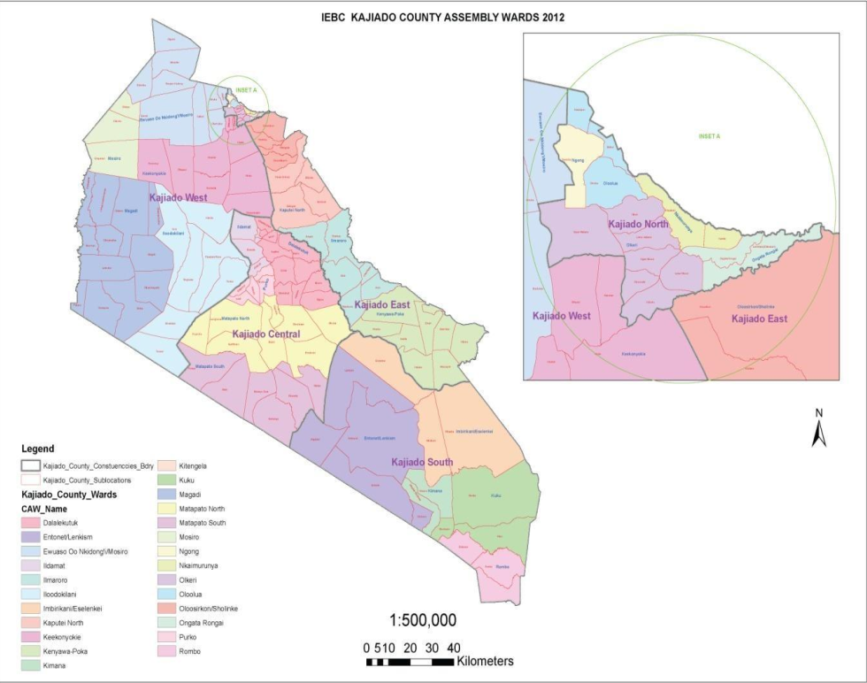

Figure 3.1: Map of Kajiado County
3.4 Target population
A population in research is defined as a group of individuals or elements sharing specific characteristics within a defined geographical or institutional boundary, which forms the focus of the study (Martínez-Mesa, 2014). In this study, the target population consisted of individuals and institutions directly or indirectly involved in quarrying activities within Kajiado East Sub-County, specifically in Enguranga Sub-County and Oloosirkon/Sholinke Ward. The common characteristic among these individuals was their direct engagement with quarrying, either economically, socially, or administratively. This included landowners who leased land for quarrying, quarry tenants and operators managing extraction activities, and workers such as machine operators and transporters whose livelihoods depended on quarry-related work. Vendors involved in supporting quarry activities were also included. In addition, the population comprised key informants such as Sub-County administrators, environmental officers, law enforcement agents, community elders, and elected leaders. These stakeholders shared the characteristic of being involved in regulatory, supervisory, or governance roles relevant to quarrying. Collectively, these groups were strategically selected because of their integral roles in or influence over quarrying operations and environmental management. Their inclusion enabled the study to gather comprehensive insights on the socio-economic and environmental impacts of quarrying and assess the sustainability of land use practices in the area..

Table 3.1: Target Population
Category | No
Landowners | 10
Quarry tenants | 20
Quarry workers | 200
Machine operators | 10
Transporters | 20
Vendors | 20
Environmental law enforcers | 10
Subcounty administrators | 10
County revenue staff | 10
Community leaders | 20
Supply chain and end users | 62
Total | 385

3.5 Study Sample
3.5.1 Sampling Procedure
According to Ogula (2005), a sampling procedure involves selecting a representative sub-group from a defined population to participate in a study. Given the heterogeneous nature of individuals engaged in quarrying activities in Kajiado East Sub-County, the study employed stratified sampling to categorize the population into ten distinct strata based on their roles and interactions with quarrying. These included quarry workers, landowners, transporters, machine operators, environmental officers, administrators, community elders, and vendors. Stratification ensured each sub-group was proportionally and fairly represented in the final sample (Creswell, 2015). A structured questionnaire was used as the primary data collection tool across all strata. This decision was informed by the need for standardized, quantifiable data to assess shared indicators such as perceptions of environmental impact, economic benefits, and land management practices. Administering a uniform tool across different respondent categories allowed for direct comparison and integration of findings. However, recognizing the specialized insights held by administrators, environmental officers, and community elders, the study supplemented the questionnaire with targeted Key Informant Interviews (KIIs). This mixed-method strategy enabled triangulation, enriching quantitative results with qualitative context, and ensuring a balanced, comprehensive understanding of quarrying’s socio-economic and environmental impacts in the area..
3.5.2. Sample Size
According to Mugenda and Mugenda (2013), a sample size refers to a smaller, representative group selected from the larger target population to participate in a study. Given the expansive nature of Kajiado East Sub-County and the limited availability of financial and time resources, the study employed sampling techniques to select a manageable yet representative subset of respondents from the population. Stratified random sampling was adopted to ensure that all key subgroups within the community were adequately represented. The population was divided into strata based on characteristics such as position, occupation, income level, education, gender, and ethnic background. From each stratum, a random sample was selected proportionately based on the relative size of each group in the overall population. This method enhanced the representativeness of the sample and allowed for the capture of diverse perspectives on quarrying activities. For determining the sample size of the general respondents (excluding key informants), the Yamane formula (1967) was applied. The formula is appropriate when the population is less than 10,000 and is expressed as:
$$N=\frac{N}{1+N(e^{2})}$$
$$n=\frac{385}{1+385(0.0025)}≈196$$
Therefore, the calculated sample size for general respondents was 196. This sample was distributed across selected villages in Kajiado East Sub-County according to the sampling matrix presented in Table 3.2. Key informants, including county officials, law enforcement personnel, and community elders, were selected purposively based on their roles and relevance to the study.

Table 3.2: sample size
Category | Target population (n) | Proportion (%) | Sample size (n = 196)
Landowners | 10 | 2.6% | 5
Quarry tenants | 20 | 5.2% | 10
Quarry workers | 200 | 51.9% | 102
Machine operators | 10 | 2.6% | 5
Transporters | 20 | 5.2% | 10
Vendors | 20 | 5.2% | 10
Environmental law enforcers | 10 | 2.6% | 5
Sub-county administrators | 10 | 2.6% | 5
County revenue staff | 10 | 2.6% | 5
Community leaders | 20 | 5.2% | 10
Supply chain and end users | 62 | 16.1% | 29
Total | 385 | 100% | 196

3.6 Data collection instruments
Data collection refers to the systematic process of gathering information from relevant sources to obtain a comprehensive and accurate understanding of an area of interest (Simon & Goes, 2013). This study employed both primary and secondary data sources to capture biophysical, socio-economic, and institutional dimensions associated with stone quarrying in Kajiado East Sub-County. Primary data were collected using questionnaires and interviews, while secondary data were sourced from official documents, reports, and satellite imagery.
3.6.1 Data Collection on Assessment of the Impacts of Stone Quarrying Activities on the Biophysical Environment
The assessment of biophysical impacts from stone quarrying relied primarily on remote sensing techniques and geospatial analysis. Remote sensing involves acquiring information about the Earth's surface without direct contact, using electromagnetic data captured by satellite sensors (Sivakumar et al., 2003). To monitor changes in vegetation and land use, satellite data were obtained from the United States Geological Survey (USGS) via Google Earth Engine (GEE). Landsat-5 TM (1993, 2003), Landsat-8 OLI/TIRS (2014), and Landsat-9 OLI-2 (2023) data were used, each offering 30-meter resolution and a 16-day revisit cycle, suitable for long-term environmental monitoring. Images were selected from January to March of each study year to minimize cloud interference, with only those containing less than 5% cloud cover utilized. Landsat-7 (2013) data were excluded due to scan line errors, replaced with 2014 data. Preprocessing on GEE included cloud masking, band combination, and mosaicking, followed by NDVI computation, zonal statistics, and change detection mapping to quantify vegetation loss and land degradation trends.
3.6.2 Data Collection to Investigate the Effects of Stone Quarrying Activities on Socio-Economic Characteristics of the Local Communities
To investigate socio-economic effects, the study employed both quantitative and qualitative methods. Structured questionnaires, containing both closed- and open-ended items (Tichapondwa, 2013), were administered to a diverse group of respondents, including landowners, quarry workers, transporters, vendors, and machine operators. These questionnaires captured data on income, employment, displacement, service access, and well-being. In addition, semi-structured interviews were conducted with key informants such as Sub-County administrators, environmental officers, community leaders, and elected representatives. Following Mwita (2022), qualitative interviews were essential for gaining deeper insights into issues like land conflicts, environmental health risks, and compensation perceptions. The study combined these tools to triangulate findings, questionnaires offering breadth and quantifiable patterns, and interviews capturing rich, context-specific narratives (Edwards & Hollands, 2013). Ethical guidelines, voluntary participation, and confidentiality were strictly observed throughout.
3.6.3 Data Collection to Appraise the Current Policy, Legal, and Institutional Framework Governing Management and Control of Stone Quarrying Activities
To assess policy, legal, and institutional frameworks governing quarrying, both primary and secondary data were collected. Primary data involved structured and semi-structured interviews with officials from NEMA, County Environment Departments, Sub-County Administrators, law enforcement officers, and elected leaders. Structured interviews maintained consistency in evaluating frameworks like EMCA 1999, the Mining Act 2016, County by-laws, and institutional mandates. Semi-structured interviews allowed flexibility in probing emerging themes such as policy overlap, enforcement gaps, and community involvement in environmental governance (Olatunde & Olenik, 2021). Secondary data were obtained from official reports, policy documents, Environmental Impact Assessments, Audit reports, strategic plans, and legal texts from NEMA, the Ministry of Environment, and Kajiado County Government. These sources provided critical context and enhanced data triangulation, improving the validity of research findings on governance structures and their effectiveness in managing quarrying impacts..

Table 3.3: Summary of Research Objectives and Corresponding Target Information for Data Collection
Objective | Target Information
Objective 1: Assess the impacts of stone quarrying activities on the biophysical environment | - Does stone quarrying affect or destroy the biophysical environment?  - How does stone quarrying destroy vegetation cover?  - What is the level or extent of vegetation cover destruction?  - Are there any environmental inspections conducted, and if so, by whom?
Objective 2: Investigate the effects of stone quarrying activities on the socio-economic characteristics of local communities | - What were the traditional socio-economic activities in the area before quarrying began?  - Apart from quarrying, what other socio-economic activities have emerged in the region?  - What additional income sources are associated with stone quarrying (e.g., transport, vending)?  - Do quarrying contract agreements include obligations for site rehabilitation?  - What are the socio-economic impacts of quarrying-related income on local communities?  - Are there preferred or alternative income-generating activities to stone quarrying?
Objective 3: Appraise the current policy, legal and institutional framework governing the management and control of quarrying activities | - Are there policies and legal frameworks that regulate stone quarrying activities?  - Are any approvals required prior to the establishment of a stone quarry?  - What successes or strengths exist in policy implementation at county/national level?  - Are there any sanctions or penalties for non-compliance, especially regarding site rehabilitation?

3.7 Piloting Testing
According to Cooper and Schindler (2011), a pilot test is conducted to identify and correct potential weaknesses in the research design, instrumentation, and procedures while also providing preliminary data to validate the suitability of tools for the actual study. For this study, pilot testing was carried out in Katani Sub County, Machakos County, which borders Kajiado County and shares similar geological and socio-economic characteristics, including active quarrying sites. Two quarry sites in Katani were selected for the piloting exercise. A total of 10 respondents were engaged, where three were purposively selected for qualitative interviews, and seven were issued with structured questionnaires. The pilot exercise helped identify ambiguities in question phrasing, logistical challenges, and respondent understanding of key terms. Based on the insights gained, adjustments were made to enhance the clarity, sequencing, and relevance of the data collection instruments, ensuring their reliability and validity prior to deployment in the main study area.
3.8 Reliability
Reliability refers to the consistency or repeatability of results when similar procedures are used under comparable conditions (Mugenda & Mugenda, 2003). It reflects the extent to which a research instrument produces stable and consistent outcomes. In this study, reliability was assessed through a pilot test conducted prior to the main data collection. The aim was to evaluate the consistency of responses and identify any ambiguities or weaknesses in the research instruments. Continuous consultations with academic supervisors at each stage of instrument design and data collection further enhanced the reliability of the study. To statistically assess internal consistency reliability, Cronbach’s Alpha coefficient was calculated for the 41 items included in the questionnaire. As indicated in Table 3.3, the instrument achieved a Cronbach’s Alpha value of 0.953, which surpasses the generally accepted threshold of 0.7. A value above 0.9 signifies excellent reliability, suggesting that the items exhibit high internal consistency in measuring the intended constructs. This strong reliability score confirms that the questionnaire was dependable and that the data collected can be used confidently in further statistical analyses, such as correlation, regression, and hypothesis testing. The high-reliability coefficient thus enhances the credibility, accuracy, and validity of the study's findings.

Table 3.3: Reliability Statistics
Cronbach's Alpha | N of Items
0.953 | 41

3.9 Validity
Validity refers to the extent to which an instrument accurately measures what it is intended to measure and how well the research findings reflect the true situation (Cooper & Schindler, 2015). It addresses the accuracy, truthfulness, and meaningfulness of the data and interpretations derived from a research instrument in the context of the study. According to Cohen, Manion, and Morrison (2011), for an instrument to be valid, it must produce results that are a true representation of the concept being measured. This highlights the importance of ensuring that the test items fully represent the content domain relevant to the study objectives. To ensure validity, the study employed a pilot test prior to actual data collection, allowing the researcher to assess whether the instruments adequately captured the intended variables and to make adjustments as necessary (Best & Khan, 2002). Further, test-retest reliability and the coefficient of stability were considered, as recommended by Orodho (2005), to guarantee consistency in responses over time. Additionally, the research tools underwent expert review and consultation with supervisors to ensure content and face validity. These measures collectively enhanced the construct validity and overall trustworthiness of the data, making the instruments suitable for generating accurate and credible findings.
3.10 Data processing and analysis
3.10.1 To Assess the Impacts of Stone Quarrying Activities on the Biophysical Environment
To assess the impacts of stone quarrying on the biophysical environment, satellite imagery will be employed using sensors capable of detecting vegetation changes over time. These sensors will monitor and record vegetation conditions before, during, and after quarrying activities. Depending on the type of sensor and the level of data processing, image acquisition will be either continuous (at daily intervals) or event-triggered by significant vegetation loss, allowing for the collection of consistent temporal data. This data will be tabulated or graphed for use in statistical analysis. According to Ahmed (2016), vegetation indices such as the Normalized Difference Vegetation Index (NDVI) are crucial in remote sensing for tracking vegetation health and density over time. NDVI quantifies vegetation greenness and is computed using the formula NDVI = (NIR - R) / (NIR + R), where NIR represents near-infrared reflectance and R represents red reflectance. NDVI values provide a reliable measure for detecting vegetation degradation, thereby indicating the extent of environmental disturbance caused by quarrying activities. Vegetation biophysical characteristics will be derived from spectral bands in the Visible (VIS), Near Infrared (NIR), and Mid-Infrared (MIR) portions of the electromagnetic spectrum. Additionally, satellite image metadata will be used to accurately interpret reflectance or radiance values. This metadata includes details on image projection, geolocation, acquisition time, sensor attitude, environmental conditions, and calibration parameters, all of which are essential for conducting precise and reproducible image analyses. The combination of NDVI analysis and metadata interpretation will enable a statistically grounded evaluation of how stone quarrying has altered the local biophysical environment.
3.10.2 To Investigate the Effects of Quarrying Activities on Socio-Economic Characteristics of Local Communities
To investigate the socio-economic effects of quarrying activities on local communities, data collected through questionnaires were first coded to allow for systematic classification and tabulation. The Statistical Package for the Social Sciences (SPSS) version 26.0 was employed to analyze the quantitative data obtained. Descriptive statistics, including frequencies, percentages, and cross-tabulations, were used to summarise the data and identify preliminary patterns between dependent variables (socioeconomic indicators) and independent variables (quarrying activities). To establish whether there was a statistically significant association between quarrying activities and changes in socio-economic characteristics, the Chi-square test of independence (χ²) was applied. The Chi-square formula is given as:
$$x^{2}=\frac{\sum{}{(O-E)}^{2}}{E}$$
Where:
O = Observed frequency
E = Expected frequency
This test is appropriate for categorical data and was used to determine if there is a significant relationship between variables, particularly whether observed socio-economic conditions deviate significantly from what would be expected in the absence of quarrying activities. By comparing the observed distribution of socioeconomic outcomes with expected distributions under the null hypothesis, the Chi-square statistic helps the researcher determine whether quarrying activities are statistically associated with changes in community livelihoods, income patterns, health conditions, employment, and access to social amenities. This analytical approach supports valid inferential conclusions regarding the socio-economic implications of quarrying in the study area.
3.10.3 To Appraise the Current Policy, Legal, and Institutional Framework Governing Management and Control of Stone Quarrying Activities
To analyze data related to the current policy, legal, and institutional framework, the study employed thematic analysis, a widely used qualitative technique for interpreting textual and narrative data. According to Vaismoradi et al. (2016), thematic analysis is a flexible method used to identify and report patterns (themes) within qualitative data, facilitating a deeper understanding of complex phenomena. Nowell et al. (2017) further emphasize that thematic analysis is applicable across various epistemological approaches and research questions, making it suitable for analyzing interview transcripts, focus group discussions, and secondary textual sources. In this study, thematic analysis was applied to qualitative data collected from semi-structured interviews with key informants, including policymakers, environmental officers, and community leaders, as well as secondary data from reports by regulatory bodies such as the National Environment Management Authority (NEMA) and the County Department of Environment. Additionally, relevant insights were drawn from official documents, policy guidelines, internet-based commentaries, and existing literature. The process involved identifying recurring themes related to regulatory enforcement, policy effectiveness, legal compliance, institutional capacity, and community participation. These themes were then coded manually, though software such as NVivo could also be employed for advanced coding and analysis. The data coding focused on extracting the meaning, relevance, and frequency of policy-related issues highlighted by the respondents. This approach enabled the characterisation and interpretation of participant perspectives in relation to existing legal and institutional mechanisms. Furthermore, secondary data from NEMA and other official sources were compiled and utilised for correlation testing, facilitating the triangulation of findings to assess the alignment between policy provisions and observed outcomes in the management of quarrying activities. Overall, the thematic analysis provided rich, contextualized insights into the strengths and weaknesses of the existing frameworks and informed policy recommendations for more sustainable quarrying practices.
3.11 Legal and Ethical Considerations
The study adhered to ethical and legal standards, ensuring voluntary participation without coercion, as supported by Gall et al. (2007). Approvals were obtained from Africa Nazarene University (ANU), the National Commission for Science, Technology and Innovation (NACOSTI), and relevant local authorities. Informed consent was secured from all respondents, who were assured of their right to withdraw at any point. The research maintained confidentiality and ensured responsible handling of all non-public data. Ethical integrity was maintained by giving due credit to all sources and employing an objective and transparent approach in data collection, analysis, and reporting. The study prioritized honesty, respect for participants, and compliance with all institutional and legal requirements throughout the research process.

CHAPTER FOUR

DATA ANALYSIS AND FINDINGS
4.1. Introduction
This chapter presents the research findings and interpretation of the data results. The descriptive findings and inferential statistics were presented in tables.
4.2. Response Rate of Data Collection Instruments
The researcher distributed 196 questionnaires to the participants in the study. From the questionnaires issued, 186 were filled in and returned; this represented an 83.78% response rate as shown in Table 4.1.

Table 4.1: Response rate
Responses | Frequency | Percentage
Returned | 186 | 83.78%
Not returned | 10 | 16.22%
Issued questionnaires | 196 | 100.00%
Source: Author, 2025
A response rate of 83.78% is considered exceptionally high for survey-based research. According to Babbie (2020), a response rate above 70% is typically regarded as very good in social science research, as it minimizes the risk of non-response bias and enhances the representativeness of the sample. The high response rate achieved in this study suggests that the findings are likely to be representative of the views and experiences of the target population, thereby enhancing the external validity of the results. The high participation level could be attributed to several factors, including the strategic follow-up measures employed by the research team, clear communication of the study’s purpose, and assurances of confidentiality. Additionally, the relevance and perceived importance of the study topic to the participants may have contributed to their willingness to participate in the study.
4.3. Demographic Characteristics of the Participants
The section highlights the demographic characteristics of the participants, including their gender, age, occupation, and residential status.
The gender of the participants was recorded, and the outcome was presented in Table 4.2.

Table 4.2: Gender of participants
 | N | %
Male | 108 | 58.1%
Female | 78 | 41.9%
Total | 186 | 100.00%
Source: Author, 2025
Table 4.2 summarizes the gender distribution of the participants who participated in the study. Out of the 186 participants, 108 (58.1%) were male, while 78 (41.9%) were female. This indicates a moderate gender imbalance among participants, with male participants constituting a slight majority. The findings indicate a relatively balanced gender representation, with a slight predominance of male participants. The male-to-female ratio stands at approximately 1.38:1, suggesting that while both genders were adequately represented, there were more male than female participants. This distribution may reflect the actual gender composition of the target population within the context of this study, potentially influenced by occupational roles, organisational demographics, or industry-specific trends in gender participation. The age of the participants was recorded and the outcome presented in Table 4.3.

Table 4.3: Age of participants
 | N | %
Below 18 Years | 18 | 9.7%
Between 18 - 30 Years | 78 | 41.9%
Between 31 - 50 Years | 72 | 38.7%
Above 50 Years | 18 | 9.7%
Total | 186 | 100.00%
Source: Author, 2025
Table 4.3 presents the age distribution of the participants who participated in the study. Among the 186 participants, 18 participants (9.7%) were aged below 18 years. The largest proportion of participants, comprising 78 individuals (41.9%), fell within the 18- to 30-year age bracket. This was closely followed by the 31 to 50 -year-old age group, which included 72 participants (38.7%). Additionally, 18 participants (9.7%) were above 50 years of age. This distribution suggests that the study primarily engaged a relatively young and middle-aged workforce, which is reflective of the typical employment demographics in many Kenyan organizational settings. The predominance of participants within the 18 to 50-year age bracket (80.6%) indicates that the views captured predominantly represent the perspectives of the most active and professionally engaged segment of the population.
The occupation of the participants was recorded, and the outcome was presented in Table 4.4.

Table 4.4: Occupation of the participants
 | N | %
Quarry worker | 41 | 22.0%
Farmer | 66 | 35.5%
Public officers | 42 | 22.6%
Local leader | 18 | 9.7%
Other specify | 19 | 10.2%
Total | 186 | 100.00%
Source: Author, 2025
Table 4.4 summarizes the occupational distribution of the participants, revealing that the largest proportion were farmers, totalling 66 individuals (35.5%) out of the 186 participants. This was followed closely by public officers, who accounted for 42 participants (22.6%), and quarry workers, who made up 41 participants (22.0%). Local leaders comprised 18 participants (9.7%), while 19 participants (10.2%) indicated other occupations not specified in the questionnaire. This occupational distribution demonstrates a diverse respondent base, reflecting the varied socio-economic roles within the study area.
The residential status of the participants was recorded, and the outcome was presented in Table 4.5.

Table 4.5: Residential status
 | N | %
Near a quarry less 5 km | 108 | 58.1%
Far more than 5 km from a quarry | 78 | 41.9%
Total | 186 | 100.00%
Source: Author, 2025
Table 4.5 presents the residential status of the participants based on their proximity to a quarry. Out of the 186 participants, 108 participants (58.1%) reported residing near a quarry, specifically within a radius of less than 5 kilometres, while 78 participants (41.9%) indicated living farther than 5 kilometres from a quarry. This distribution reveals that a majority of the participants reside near quarrying activities, which is significant given the study’s focus on quarry-related impacts and community perceptions. The predominance of participants living within 5 kilometres suggests that the data predominantly reflect the experiences and viewpoints of those most directly affected by quarry operations. According to Mugenda and Mugenda (2003), the proximity of participants to the phenomena under investigation enhances the relevance and reliability of data, as it captures firsthand experiences of the affected population. The presence of 41.9% of participants living farther away ensures that comparative perspectives are also represented, enabling a broader analysis of how residential distance influences perceptions or outcomes related to quarry activities. This balanced yet proximity-weighted distribution supports a comprehensive and contextually grounded interpretation of the findings.
4.4. Findings For Objective One: Impacts of Stone Quarrying Activities on the Biophysical Environment
The participants were provided with Likert-scale questions that touched on the impacts of stone quarrying activities, with a focus on their impact on land and soil, flora and fauna, water resources, and pollution. The outcomes were presented in Table 4.6.

Table 4.6: Stone Quarrying Activities and Sustainable Environmental Management
Item | Mean | Std. Dev | CV (%)
Stone quarrying activities have caused visible land degradation in my area. | 3.516 | 1.015 | 28.86
Quarrying activities have changed the local topography or land relief. | 3.839 | 0.886 | 23.08
There are active reclamation or rehabilitation efforts after quarrying activities. | 3.742 | 0.917 | 24.51
Reclamation efforts have been effective in restoring the land. | 3.806 | 0.822 | 21.60
Local plant species have been negatively impacted by quarrying activities. | 4.097 | 0.931 | 22.72
Quarrying activities have negatively affected local wildlife and biodiversity. | 3.871 | 0.753 | 19.45
I have observed an increase in invasive plant or animal species due to quarrying. | 3.968 | 0.935 | 23.57
Conservation efforts are in place to protect local biodiversity in my area. | 4.097 | 0.858 | 20.95
Stone quarrying activities have negatively affected water quality in my area. | 3.452 | 1.163 | 33.68
Quarrying has led to a reduction in local groundwater levels. | 3.452 | 0.838 | 24.29
Quarrying has caused the destruction or diversion of water bodies (rivers, streams, wetlands). | 3.161 | 0.990 | 31.30
Quarrying activities have caused air pollution in my area. | 3.452 | 0.981 | 28.42
Dust pollution from quarrying activities has affected the local community. | 3.645 | 0.971 | 26.65
Noise pollution from quarrying activities has been a problem in the area. | 3.452 | 1.014 | 29.37
Composite Mean and standard deviation | 3.682 | 0.934
delete
From Table 4.6, the analysis of responses on visible land degradation due to stone quarrying revealed a mean score of 3.516 with a standard deviation (SD) of 1.015 and a coefficient of variation (CV) of 28.86%. The mean score indicates that many participants agreed that quarrying activities have caused observable land degradation in their vicinity, though the score is slightly below the composite mean of 3.682. The standard deviation (SD) of 1.015 exceeds the composite SD of 0.934, and the coefficient of variation (CV) is relatively high, indicating moderate variability in perceptions among participants.
The responses to the question about changes in local topography due to quarrying activities had a mean of 3.839, a standard deviation (SD) of 0.886, and a coefficient of variation (CV) of 23.08%. The mean was notably higher than the composite mean of 3.682, demonstrating strong agreement among participants that quarrying had significantly altered the physical landscape. The SD was lower than the composite SD (0.934), and the CV was also below the composite average, indicating relatively consistent perceptions regarding topographical changes. This suggested that the impact on land relief was both observable and widely acknowledged by community members.
The item assessing the presence of active reclamation or rehabilitation efforts following quarrying activities received a mean score of 3.742, a standard deviation (SD) of 0.917, and a coefficient of variation (CV) of 24.51%. This mean was above the composite mean of 3.682, indicating that most participants perceived reclamation efforts as actively being implemented in their areas. The SD and CV values indicated a moderate level of agreement, with some variation in responses, reflecting differences in the visibility, scale, or effectiveness of rehabilitation programs across locations.
On the item “Reclamation efforts have been effective in restoring the land,” participants moderately agreed that reclamation efforts have been effective in restoring quarry-affected land, as reflected by a mean score of 3.806, which is above the composite mean of 3.682. The standard deviation (SD) of 0.822 and coefficient of variation (CV) of 21.60% indicated relatively low variability in responses, suggesting a consensus on the perceived effectiveness of rehabilitation activities. This relatively strong agreement and tighter clustering of responses point to the successful implementation of reclamation measures in some quarry areas.
The perception that quarrying activities have negatively affected local plant species was strongly agreed upon, as indicated by a high mean score of 4.097, exceeding the composite mean of 3.682. The standard deviation (SD) of 0.931 and coefficient of variation (CV) of 22.72% suggest a moderate level of consensus among participants, with most recognising significant ecological damage to vegetation in their areas. These results highlight the urgent need for more comprehensive ecological monitoring and restoration initiatives focused on native vegetation to mitigate biodiversity loss and maintain ecosystem resilience in quarry–affected areas.
The item assessing perceptions of increased invasive species due to quarrying activities garnered a mean score of 3.968, which is notably higher than the composite mean of 3.682, reflecting general agreement among participants. The standard deviation (SD) of 0.935 and the coefficient of variation (CV) of 23.57% suggest moderate variability, indicating some differences in the extent to which this phenomenon is observed across locations. Such disturbances often result from soil exposure, reduced vegetation cover, and altered microhabitats typical of quarry sites. The moderate variation in responses may reflect differing degrees of invasive species presence, depending on local environmental management and restoration efforts.
On the statement that “Conservation efforts are in place to protect local biodiversity in my area,” the participants strongly agreed that conservation efforts exist to protect local biodiversity, with a mean score of 4.097, surpassing the composite mean of 3.682. The standard deviation (SD) of 0.858 and coefficient of variation (CV) of 20.95% indicate a moderate consensus, suggesting that most community members are aware of active conservation initiatives, although some variation exists in their perception. Awareness and participation in such initiatives often enhance their success and promote stewardship among affected populations.
The perception that stone quarrying has negatively impacted water quality was moderately agreed upon, with a mean score of 3.452, which is below the composite mean of 3.682. The standard deviation (SD) was relatively high at 1.163, and the coefficient of variation (CV) stood at 33.68%, indicating substantial variability in participants’ views. This high variability suggests that the perceived impact on water quality is not uniform across all locations, potentially reflecting differences in proximity to quarry sites, local hydrological conditions, or mitigation measures. The SD being higher than the composite (0.934) further reinforces that responses were more dispersed for this item. The moderate agreement, coupled with high variability, highlighting the need for localised water quality monitoring and targeted interventions to protect vulnerable water sources. Given the essential role of clean water in community health and agriculture, addressing these water quality concerns is critical in quarry management policies.
Further, participants moderately agreed that quarrying activities have contributed to a reduction in local groundwater levels, as indicated by a mean score of 3.452, slightly below the composite mean of 3.682. The standard deviation (SD) was 0.838, which is lower than the composite SD of 0.934, indicating relatively consistent perceptions among participants. The coefficient of variation (CV) was 24.29%, reflecting moderate variability in responses. The moderate agreement suggests that while groundwater depletion is a recognized concern, it may not be uniformly experienced across all locations. The relatively lower standard deviation (SD) indicates a somewhat shared community experience or awareness regarding groundwater changes. Given the critical role groundwater plays in domestic use and irrigation, these findings underscore the need for rigorous hydrogeological assessments and sustainable quarrying practices to mitigate risks of groundwater depletion.
The participants’ views on whether quarrying has caused destruction or diversion of water bodies recorded a mean score of 3.161, which is notably lower than the composite mean of 3.682. The standard deviation (SD) was 0.990, and the coefficient of variation (CV) was 31.30%, indicating considerable variability and less consensus among participants. The lower mean suggests that while some participants have observed such negative impacts on rivers, streams, or wetlands, others either have not experienced or do not perceive these effects to the same extent. This disparity could arise from differences in quarry proximity to water bodies or the implementation of environmental safeguards. The relatively high standard deviation (SD) and coefficient of variation (CV) further highlight divergent experiences or awareness levels regarding water body destruction or diversion.
The perception of quarrying-related air pollution yielded a mean score of 3.452, which is lower than the composite mean of 3.682, with a standard deviation (SD) of 0.981 and a coefficient of variation (CV) of 28.42%. These results indicate a moderate level of agreement among participants, as reflected in the relatively high standard deviation (SD) and coefficient of variation (CV), which suggest some variability in experiences or perceptions. The mean being lower than the composite suggests that air pollution, while acknowledged, may not be uniformly severe or noticeable across all areas. The moderate variability in responses highlights differences in exposure or sensitivity among residents. Addressing air quality through improved operational controls, such as water spraying and the use of vegetation buffers, is essential to mitigate health risks and enhance community well-being.
The analysis of responses regarding dust pollution from quarrying revealed a mean score of 3.645, which is slightly below the composite mean of 3.682. The standard deviation (SD) was 0.971, and the coefficient of variation (CV) stood at 26.65%, indicating moderate agreement among participants with some variability in perceptions. The mean score reflects that many participants recognize dust pollution as a concern affecting the local community, consistent with findings by Kariuki (2021), who reported that dust generated by blasting and transportation activities in quarries contributes to respiratory problems and reduced air quality. The SD and CV values indicate that, although the issue is acknowledged, some participants may experience a lesser impact or perceive dust pollution differently, potentially due to their distance from quarry sites or local mitigation measures. The moderate variability in responses suggests that further efforts to manage dust pollution could enhance community health and environmental quality around quarry operations.
Participants indicated moderate agreement that noise pollution from quarrying activities has been problematic, with a mean score of 3.452, which is below the composite mean of 3.682. The standard deviation (SD) of 1.014 and coefficient of variation (CV) of 29.37% point to considerable variability in responses. The mean is lower than the composite, suggesting that while noise pollution is recognised as an issue, its intensity or impact may vary significantly across the community. The relatively high standard deviation (SD) and coefficient of variation (CV) further reflect differences in proximity to noise sources, participant sensitivity, or the effectiveness of noise mitigation strategies. However, noise pollution is often localized, with those closer to quarry sites experiencing more severe effects. This variability highlights the necessity for targeted noise reduction measures, including sound barriers, controlled blasting times, and community engagement, to mitigate adverse health and social impacts.
4.5. Findings For Objective Two: Socio - Economic Environment and Sustainable Environmental Management
The participants were provided with Likert-scale questions that touched on the impacts of stone quarrying activities on the socio-economic environment. The outcomes were presented in Table 4.7.

Table 4.7: Socio-Economic Environment and Sustainable Environmental Management
Item | Mean | Std. Dev | CV (%)
Stone quarrying activities have created employment opportunities in my area. | 4.000 | 0.720 | 18.00
My household income has improved due to quarrying activities. | 3.871 | 0.909 | 23.48
Quarrying has increased job opportunities and markets for goods and services in my area. | 3.935 | 0.842 | 21.40
Quarrying activities have caused economic challenges such as loss of farmland or displacement. | 4.065 | 0.984 | 24.21
Stone quarrying has improved access to essential services in my area. | 3.700 | 1.008 | 27.24
Quarrying has led to displacement or increased community conflicts. | 3.677 | 0.999 | 27.17
Quarrying has positively affected local infrastructure (roads, schools, hospitals). | 3.484 | 1.046 | 30.02
The social impacts of quarrying activities in my area have been positive. | 4.097 | 0.820 | 20.01
My family and I have experienced health issues due to quarrying activities. | 4.194 | 0.694 | 16.55
Health facilities in my area are adequate for dealing with quarrying-related health issues. | 4.129 | 0.661 | 16.01
Quarrying activities pose significant safety concerns (accidents, dust, noise) for the community. | 4.194 | 0.593 | 14.14
I perceive stone quarrying activities in my area as beneficial. | 4.032 | 0.697 | 17.29
Composite Mean and standard deviation | 3.948 | 0.831 | 21.29
Source: Author, 2025
According to Table 4.7, the findings revealed that participants strongly agreed with the statement that stone quarrying activities have created employment opportunities in their area, as reflected by a high mean score of 4.00. This value is above the composite mean of 3.948, indicating a stronger-than-average perception of quarrying as a source of employment. The standard deviation (SD) was relatively low at 0.720, and the coefficient of variation (CV) was 18.00%, both of which indicate limited variability and strong consensus among participants. The low CV confirms that most participants perceive quarrying as economically significant to local livelihoods.
On the second item, participants moderately agreed that their household income had improved because of quarrying activities, reflected by a mean score of 3.871, slightly below the composite mean of 3.948. The standard deviation (SD) was 0.909, and the coefficient of variation (CV) stood at 23.48%, indicating moderate variability in responses. This suggests that while many households have experienced financial benefits from quarrying, the extent of these gains varies considerably within the community. The moderate CV in this study suggests similar dynamics, where some families may have secure, consistent incomes from quarrying while others experience more unstable or marginal benefits, underscoring the complex socio-economic footprint of the sector.
Regarding the third item, the participants agreed that quarrying activities have expanded job opportunities and stimulated markets for goods and services within their locality, as indicated by a mean score of 3.935, which is slightly below the composite mean of 3.948. The standard deviation (SD) was 0.842, and the coefficient of variation (CV) was 21.40%, indicating relatively moderate variability in responses. This suggests a reasonably consistent recognition of quarrying’s role in spurring not only direct employment but also indirect economic activities such as retail, food vending, transportation, and tool supply. The modest CV reflects general agreement on the socio-economic ripple effects of quarrying.
The participants expressed strong agreement that quarrying activities have introduced economic challenges, particularly through the loss of farmland and displacement, reflected by a mean score of 4.065, notably higher than the composite mean of 3.948. The standard deviation (SD) was 0.984, and the coefficient of variation (CV) stood at 24.21%, indicating moderate variability in community perceptions. This finding suggests that while quarrying brings economic opportunities, it also imposes significant costs on livelihoods dependent on agricultural land, which is often lost to excavation or rendered unproductive due to dust and debris. The relatively higher SD and CV, in this case, reflect diverse experiences within the community, where some individuals face direct economic dislocation while others may be less affected.
On the fifth statement, participants moderately agreed that quarrying activities have contributed to improving access to essential services in their area, as reflected by a mean score of 3.700, which is lower than the composite mean of 3.948. The standard deviation (SD) was relatively high at 1.008, and the coefficient of variation (CV) stood at 27.24%, indicating noticeable variability in responses. This suggests that while some community members have seen tangible improvements in services such as roads, healthcare, and schools, others may not have experienced similar benefits. The moderate-to-high CV in this item indicates varying levels of infrastructural gain across the community, highlighting the importance of structured, sustainable corporate social responsibility initiatives.
Regarding the sixth item, the participants showed moderate agreement with the notion that quarrying activities have contributed to the displacement and increased community conflicts, as reflected in a mean score of 3.677, which is notably lower than the composite mean of 3.948. The standard deviation (SD) was 0.999, and the coefficient of variation (CV) stood at 27.17%, indicating moderate to high variability in responses. This variability suggests differing experiences within the community, where some have faced direct displacement or conflict while others remain less affected. The high standard deviation (SD) and coefficient of variation (CV) reflect the sensitive and localised nature of these conflicts, emphasising that while quarrying can drive economic growth, it also introduces significant social strains.
Regarding the seventh item, the findings revealed moderate agreement among participants that quarrying had a positive impact on local infrastructure, with a mean score of 3.484, which falls noticeably below the composite mean of 3.948. The standard deviation (SD) was relatively high at 1.046, while the coefficient of variation (CV) was 30.02%, indicating considerable variability in perceptions across the community. This suggests that while some participants have observed improvements in infrastructure, such as roads, schools, and healthcare facilities, others have either not experienced these changes or perceive them as insufficient. The high standard deviation (SD) and coefficient of variation (CV) in this finding reflect these disparities, underscoring the inconsistent distribution of infrastructural gains.
On item eight, the participants generally agreed that the social impacts of quarrying activities in their area have been positive, as reflected by a high mean score of 4.097, which is above the composite mean of 3.948. The standard deviation (SD) was relatively low at 0.820, and the coefficient of variation (CV) stood at 20.01%, indicating moderate agreement with limited variability. This suggests a relatively consistent perception among community members that quarrying activities have contributed to social benefits such as employment, improved livelihoods, and enhanced local services. The relatively modest CV in this study suggests general community consensus regarding the social advantages of quarrying, though it also highlights the importance of sustainable practices that balance these benefits with potential adverse effects to safeguard long-term community well-being.
Regarding item 9, the participants strongly agreed that quarrying activities have led to health issues affecting their families, as indicated by a high mean score of 4.194, which is significantly higher than the composite mean of 3.948. The standard deviation (SD) was low at 0.694, and the coefficient of variation (CV) was 16.55%, showing a high level of agreement and relatively low variability among participants. This strong consensus underscores the widespread recognition of health risks associated with quarrying, such as respiratory problems from dust exposure, noise-induced stress, and injuries related to quarry operations. The low CV reflects that these health issues are pervasive and consistently reported across the sample population.
On item ten, the Participants moderately agreed that health facilities in their area are adequate to handle quarrying-related health concerns, as indicated by a mean score of 4.129, which is notably higher than the composite mean of 3.948. The standard deviation (SD) was low at 0.661, and the coefficient of variation (CV) was 16.01%, demonstrating a strong consensus with limited variability among participants. This suggests that many community members perceive local health services as sufficiently equipped to address illnesses and injuries linked to quarrying activities. The low CV underscores a general agreement on facility adequacy; however, ongoing assessments and resource investments are vital to maintaining and improving capacity to handle health impacts effectively.
On item eleven, the participants strongly agreed that quarrying activities presented significant safety concerns, as evidenced by a high mean score of 4.194, which exceeds the composite mean of 3.948. The standard deviation (SD) was low at 0.593, and the coefficient of variation (CV) was 14.14%, reflecting a strong consensus and limited variability among respondents. This high level of agreement underscores community awareness of the multifaceted safety risks associated with quarrying, including frequent accidents, hazardous dust exposure, and disruptive noise levels. The low CV indicates that these concerns are widely shared across the sampled population, emphasizing the urgent need for stringent safety protocols, regular risk assessments, and community health education to mitigate these hazards effectively.
On item thirteen, it was noted that the majority of the participants generally perceived stone quarrying activities as beneficial, with a mean score of 4.032, which is slightly above the composite mean of 3.948. The standard deviation (SD) was 0.697, and the coefficient of variation (CV) was 17.29%, indicating moderate consensus with limited variability among respondents. This perception highlights the community’s recognition of quarrying’s positive contributions, such as job creation, economic development, and improved infrastructure. The relatively low coefficient of variation (CV) suggests that these positive perceptions are widely shared among respondents.
4.6. Findings For Objective Three: Policy, Legal, and Institutional Framework and Sustainable Environmental Management
The participants were provided with Likert-scale questions that touched on the impacts of stone quarrying activities on the socio-economic environment. The outcomes were presented in Table 4.8.

Table 4.8: Policy, Legal, and Institutional Framework and Sustainable Environmental Management
Item | Mean | Std. Dev | CV (%)
I am aware of policies and laws governing stone quarrying in my area. | 4.000 | 0.805 | 20.13
The existing legal frameworks are adequate for regulating stone quarrying. | 4.032 | 0.697 | 17.29
Quarry operators comply with legal requirements regarding quarrying. | 4.129 | 0.610 | 14.77
Institutions responsible for managing quarrying activities coordinate effectively. | 3.935 | 1.017 | 25.85
These institutions face challenges such as insufficient funding, limited expertise, or political interference. | 3.710 | 1.056 | 28.47
The current governance framework for stone quarrying is effective. | 3.968 | 0.825 | 20.79
Local communities are adequately involved in decision-making processes related to quarrying activities. | 4.000 | 0.845 | 21.12
Composite Mean and standard deviation | 3.968 | 0.836 | 21.2
Source: Author, 2025
According to Table 4.8, the outcomes demonstrated a strong awareness of policies and laws regulating stone quarrying in their area, as indicated by a mean score of 4.000, which is slightly above the composite mean of 3.968. The standard deviation (SD) was 0.805, and the coefficient of variation (CV) was 20.13%, reflecting moderate consensus with some variability in responses. This suggests that most community members have a good understanding of the regulatory environment, which is critical for promoting compliance and sustainable quarrying practices.
Regarding the second item, participants moderately agreed that the current legal frameworks are adequate for regulating stone quarrying activities, with a mean score of 4.032, which is slightly higher than the composite mean of 3.968. The standard deviation (SD) was 0.697, and the coefficient of variation (CV) stood at 17.29%, indicating relatively strong consensus and low variability among respondents. This suggests that many community members perceive the existing laws and policies as sufficiently robust to govern quarrying operations effectively. The low CV, in this case, reflects shared confidence in the adequacy of the laws, yet it also signals the necessity of focusing on effective implementation and monitoring to translate these frameworks into sustainable quarrying practices.
The participants generally agreed that quarry operators comply with legal requirements, as shown by a mean score of 4.129, which is higher than the composite mean of 3.968. The standard deviation (SD) was low at 0.610, and the coefficient of variation (CV) was 14.77%, indicating strong consensus and low variability among participants. This reflects a widespread perception that quarry operators adhere to regulatory standards, which is crucial for minimizing environmental degradation and ensuring community safety. The low CV demonstrates that most respondents consistently view operator compliance positively, reinforcing the importance of maintaining stringent enforcement mechanisms and promoting transparency to sustain this trend.
Item four outcomes showed a moderate agreement regarding the effectiveness of coordination among institutions managing quarrying activities, reflected by a mean score of 3.935, slightly below the composite mean of 3.968. The standard deviation (SD) was relatively high at 1.017, and the coefficient of variation (CV) was 25.85%, indicating considerable variability in perceptions. This suggests that while some respondents believe institutions work well together to regulate quarrying, others perceive gaps or challenges in coordination. The high standard deviation (SD) and coefficient of variation (CV) underscore the inconsistent experiences within the community regarding institutional collaboration.
Respondents moderately agreed that institutions managing quarrying face significant challenges, with a mean score of 3.710, which is lower than the composite mean of 3.968. The standard deviation (SD) was relatively high at 1.056, and the coefficient of variation (CV) was 28.47%, indicating considerable variability in responses. This suggests that while some community members recognize the difficulties institutions face, others may be less aware of or perceive these challenges differently. The high standard deviation (SD) and coefficient of variation (CV) indicate divergent perceptions about the severity or visibility of these challenges within the community.
Regarding item six, the participants moderately agreed that the current governance framework for stone quarrying is effective, as reflected in a mean score of 3.968, which aligns with the composite mean. The standard deviation (SD) was 0.825, and the coefficient of variation (CV) was 20.79%, indicating moderate agreement with some variability among respondents. This suggests a balanced perception, with some community members viewing governance as adequate while others recognize room for improvement. The moderate CV indicates that perceptions vary, likely due to differing experiences across regions or between stakeholders.
On item seven, participants agreed that local communities are adequately involved in decision-making regarding quarrying activities, reflected by a mean score of 4.000, slightly above the composite mean of 3.968. The standard deviation (SD) was 0.845, and the coefficient of variation (CV) was 21.12%, indicating moderate consensus with some variability among respondents. This suggests that many community members feel their voices are considered in quarrying governance, which is essential for promoting transparency, trust, and sustainable practices. The moderate CV signals differing experiences within the community, underscoring the need to strengthen participatory platforms and ensure inclusive decision-making that genuinely reflects community interests in quarry management.
4.7. Inferential statistics
The study sought to establish the relationship between the study variables and the outcomes presented in this section.
4.7.1. Correlational analysis between stone quarrying activities and NDVI of vegetation cover
To examine the relationship between stone quarrying activities, socio-economic impacts, policy and institutional frameworks, and the Normalised Difference Vegetation Index (NDVI) of vegetation cover, Pearson product-moment correlation coefficients were computed. This analysis sought to determine whether the intensity of quarrying activities and associated socio-economic and regulatory factors were significantly associated with variations in remotely sensed vegetation cover within Kajiado East Sub-County. The results are summarized in Table 4.9.

Table 4.9: Correlational analysis between stone quarrying activities and NDVI of vegetation cover
 |  | NDVI of vegetation cover
Stone Quarrying Activities on the Biophysical Environment | Pearson Correlation | -.003
Stone Quarrying Activities on the Biophysical Environment | Sig. (2-tailed) | .973
Stone Quarrying Activities on the Biophysical Environment | N | 186
Impacts on the Socio-Economic Environment | Pearson Correlation | -.001
Impacts on the Socio-Economic Environment | Sig. (2-tailed) | .990
Impacts on the Socio-Economic Environment | N | 186
Policy Legal and Institutional Framework | Pearson Correlation | -.006
Policy Legal and Institutional Framework | Sig. (2-tailed) | .939
Policy Legal and Institutional Framework | N | 186
NDVI of vegetation cover | Pearson Correlation | 1
NDVI of vegetation cover | N | 186
As shown in Table 4.6, the Pearson correlation analysis revealed no significant relationship between the NDVI of vegetation cover and the other study variables. The correlation between stone quarrying activities on the biophysical environment and NDVI was r = -0.003, p = .973, indicating a negligible and statistically non-significant negative association. Similarly, the correlation between impacts on the socio-economic environment and NDVI was r = -0.001, p = 0.990, while that of policy, legal, and institutional frameworks and NDVI was r = -0.006, p = 0.939. These findings suggest that within the study context, variations in NDVI-measured vegetation cover were statistically independent of the intensity of quarrying activities, socio-economic impacts, and the presence of policy and regulatory interventions.
4.7.2. Regression analysis between stone quarrying activities and NDVI of vegetation cover
To further assess the predictive capacity of stone quarrying activities on NDVI of vegetation cover, a simple linear regression model was fitted. The model summary statistics are presented in Table 4.10.

Table 4.10: Model Summary
Model | R | R Square | Adjusted R Square | Std. Error of the Estimate | R Square Change | Sig. F Change | Durbin-Watson
1 | .003ª | .000 | -.005 | .626281 | .000 | .973 | 2.578
a. Predictors: (Constant), Stone Quarrying Activities
b. Dependent Variable: NDVI of vegetation cover
As indicated in Table 4.7, linear regression analysis was conducted to assess whether stone quarrying activities significantly predict NDVI vegetation cover in the study area. The model accounted for a negligible proportion of variance in NDVI (R² = 0.000), and the overall regression was not statistically significant, F(1, 184) = 0.001, p = 0.973. The adjusted R² was negative (−.005), indicating the model had no explanatory power beyond chance. The Durbin-Watson statistic was 2.578, suggesting no significant autocorrelation in the residuals. These findings indicate that stone quarrying activities do not significantly influence NDVI vegetation cover in the study area, thereby supporting the null hypothesis (H₀). The absence of a significant relationship (p = .973) implies that quarrying operations have not measurably affected vegetation greenness or density detectable through NDVI indices. This could be attributed to effective environmental management, reclamation efforts, or the spatial scale and timing of data collection. These findings contrast with prior studies that reported negative impacts of quarrying on vegetation health and cover (Mwangi et al., 2023; Smith et al., 2022). It is possible that the vegetation changes induced by quarrying activities require a more extended period to become evident or occur in micro-locations not adequately captured by the NDVI data. Alternatively, the resilience or regrowth of vegetation following quarrying may have mitigated observable degradation.
An analysis of variance (ANOVA) was performed to evaluate whether the regression model statistically significantly predicts the NDVI of vegetation cover based on stone quarrying activities on the biophysical environment. The results of this analysis are presented in Table 4.11.

Table 4.11: ANOVAª
Model |  | Sum of Squares | df | Mean Square | F | Sig.
1 | Regression | .000 | 1 | .000 | .001 | .973^{b}
1 | Residual | 72.170 | 184 | .392
1 | Total | 72.170 | 185
a. Dependent Variable: NDVI of vegetation cover
b. Predictors: (Constant), Stone Quarrying Activities
An analysis of variance (ANOVA) was conducted to determine whether a significant relationship exists between stone quarrying activities and NDVI of vegetation cover in the study area. The regression model was not statistically significant, F(1, 184) = 0.001, p = 0.973, indicating that quarrying activities did not have a significant effect on NDVI values. The findings from the ANOVA suggest that stone quarrying activities, as assessed in this study, do not significantly influence NDVI vegetation cover within the study area. This outcome leads to the acceptance of the null hypothesis (H₀), which posits no significant relationship between quarrying activities and NDVI values. The insignificance of the relationship (F(1, 184) = 0.001, p = .973) may imply that either the quarrying activities have not yet caused measurable impacts on vegetation cover as captured by NDVI within the temporal or spatial scale of this study, or that other intervening environmental factors are maintaining vegetation density despite quarrying operations. This finding contrasts with that of Mwangi et al. (2023) and Smith et al. (2022), who observed strong negative impacts of quarrying on vegetation health using remote sensing indices, such as NDVI. The discrepancy may result from contextual factors such as quarry management practices, differences in reclamation activities, or the resilience of local vegetation types.
The regression coefficients were examined to assess the specific contribution of stone quarrying activities on the biophysical environment in predicting NDVI of vegetation cover. The detailed results are presented in Table 4.12.

Table 4.12: Coefficients
Model |  | Unstandardized Coefficients |  | Standardized Coefficients | t | Sig. | Collinearity Statistics
 |  | B | Std. Error | Beta | t | Sig. | Tolerance | VIF
1 | (Constant) | 4.227 | .236 |  | 17.928 | .000
1 | Stone quarrying activities. | -.002 | .063 | -.003 | -.034 | .973 | 1.000 | 1.000
a. Dependent Variable: NDVI of vegetation cover
The coefficients table further confirms the lack of a significant relationship between stone quarrying activities and NDVI values in the study area. The unstandardized regression coefficient (B = -0.002) suggests that for each unit increase in quarrying activity, NDVI decreases by a mere 0.002 units, a trivial and statistically insignificant change (p = .973). The standardized coefficient (β = -0.003) reinforces this negligible effect size. This outcome aligns with the earlier ANOVA and model summary results, collectively supporting the null hypothesis (H₀). In contrast to previous research (Mwangi et al., 2023; Ouma et al., 2021), which documented significant NDVI reductions in active quarrying zones due to land degradation and vegetation loss, the current study reveals no discernible impact of quarrying on vegetation greenness. This may be attributed to effective land management practices, short-term data capture windows, or limited spatial influence of quarries relative to the broader vegetative landscape. The findings suggest that immediate ecological consequences of quarrying on vegetative cover in the study area may be either mitigated or not yet detectable by remote sensing tools.

Table 4.13: Chi-Square Tests
 | Value | df | Asymptotic Significance (2-sided)
Pearson Chi-Square | 229.148ª | 216 | .257
Likelihood Ratio | 228.189 | 216 | .272
Linear-by-Linear Association | .466 | 1 | .495
N of Valid Cases | 186
a. 245 cells (99.2%) have expected count less than 5. The minimum expected count is .19.
The Chi-Square test results indicated that there was no statistically significant relationship between quarrying activities and the biophysical or socio-economic environment in Kajiado East Sub-County. The Pearson Chi-Square value was 229.148 with 216 degrees of freedom and an asymptotic significance (p-value) of 0.257, which is greater than the conventional threshold of 0.05. Similarly, the Likelihood Ratio yielded a p-value of 0.272, and the Linear-by-Linear Association test showed a p-value of 0.495, both suggesting that the observed associations were not statistically significant. These results led to the failure to reject the null hypothesis, indicating that no significant association could be established between the variables under analysis using this test. However, it is important to interpret these findings with caution because 99.2% of the cells (245 out of 247) had expected frequencies less than 5, with the minimum expected count being 0.19. This violates a key assumption of the Chi-Square test, which requires a majority of cells to have expected counts of 5 or more for the results to be reliable. The high number of low expected counts likely weakened the test's power, making it difficult to detect actual relationships that may exist. Therefore, while the results suggest a lack of significant association, they may be inconclusive due to the limitations in the data structure. Future analyses should consider re-categorising variables, reducing the number of comparison groups, or applying alternative statistical methods more suitable for datasets with small, expected frequencies.
The study tested the null hypothesis (H₀) stating that there is no significant relationship between stone quarrying activities and NDVI of vegetation cover in the study area. Based on the findings, the hypothesis was accepted. The simple linear regression analysis indicated no statistically significant predictive relationship between stone quarrying activities and NDVI values (R² = 0.000, F(1,184) = 0.001, p = .973). Similarly, the ANOVA results confirmed the insignificance of the model (p = .973). The regression coefficients showed a trivial and non-significant effect (B = -0.002, p = .973). Furthermore, the Chi-Square test also yielded non-significant results (Pearson Chi-Square p = .257), with limitations noted due to low expected cell counts. Consequently, the null hypothesis was retained, indicating that, within the temporal and spatial scope of this study, stone quarrying activities did not have a statistically measurable effect on NDVI vegetation cover in Kajiado East Sub-County.
4.7.3. Regression analysis between the local’s income and quarrying activities in the study area
To further assess the predictive capacity of stone quarrying activities on impacts on the Socio-Economic Environment, a simple linear regression model was fitted. The model summary statistics are presented in Table 4.16.
Model Summary
Model | R | R Square | Adjusted R Square | Std. Error of the Estimate |  | Durbin-Watson
 |  |  |  |  | Sig. F Change | Durbin-Watson
1 | .675ª | .455 | .452 | .455483 | .000 | 1.812
a. Predictors: (Constant), Stone Quarrying Activities on the Biophysical Environment
b. Dependent Variable: Impacts on the Socio-Economic Environment
Source: Author, 2025
The simple linear regression analysis revealed that stone quarrying activities significantly predict impacts on the socio-economic environment, with R² = 0.455 and F(1, 184) = 153.47, p < .001. The model explained approximately 45.5% of the variance in socio-economic impacts, with a moderate to strong correlation (R = 0.675) and a Durbin-Watson statistic of 1.812, indicating no major autocorrelation issues. The model summary indicates that stone quarrying activities substantially explain changes in the socio-economic environment within the study area, accounting for 45.5% of the variance. The moderate-to-strong positive correlation (R = 0.675) implies that increased quarrying activity is associated with heightened socio-economic effects, both positive and negative. This relationship was statistically significant (p < .001), confirming the notable socio-economic footprint of extractive industries in peri-urban and rural landscapes. Moreover, the Durbin-Watson value of 1.812 falls within the acceptable range (1.5–2.5), suggesting no serious autocorrelation in residuals. This adds robustness to the model’s predictive validity.
ANOVAª
Model |  | Sum of Squares | df | Mean Square | F | Sig.
1 | Regression | 31.883 | 1 | 31.883 | 153.680 | .000^{b}
1 | Residual | 38.173 | 184 | .207
1 | Total | 70.056 | 185
a. Dependent Variable: Impacts on the Socio-Economic Environment
b. Predictors: (Constant), Stone Quarrying Activities on the Biophysical Environment

Source: Author, 2025
The ANOVA results from the regression analysis showed that the model was statistically significant, F (1, 184) = 153.68, p < .001, indicating that stone quarrying activities have a significant predictive effect on socio-economic impacts within the study area. The ANOVA output demonstrated that the regression model predicting socio-economic impacts from stone quarrying activities was statistically significant, F (1, 184) = 153.680, p < .001. This highly significant F-value confirms that the model explains a substantial amount of the variance in socio-economic outcomes beyond what would be expected by chance alone. In other words, the relationship between quarrying activities and socio-economic changes is not random but systematic and meaningful within the study area. The sizeable sum of squares for the regression (31.883) relative to the residual sum (38.173) further highlights the model's explanatory strength. These results reinforce the necessity for integrated policy frameworks that can harness the economic potential of quarrying while safeguarding social welfare and community stability (Mutua & Mwanzia, 2022).
Coefficientsª
Model |  | Unstandardized Coefficients |  | Standardized Coefficients | t | Sig. | Collinearity Statistics
 |  | B | Std. Error | Beta | t | Sig. | Tolerance | VIF
1 | (Constant) | 1.864 | .171 |  | 10.869 | .000
1 | Stone Quarrying Activities on the Biophysical Environment | .566 | .046 | .675 | 12.397 | .000 | 1.000 | 1.000
a. Dependent Variable: Impacts on the Socio-Economic Environment
Source: Author, 2025
The coefficients table reveals that stone quarrying activities on the biophysical environment significantly predict socio-economic impacts in the study area. The unstandardized coefficient (B = 0.566) indicates that for every one-unit increase in perceived quarrying activity, there is a corresponding increase of 0.566 units in the socio-economic impact score. The standardized beta coefficient (β = 0.675) suggests a strong positive relationship, with stone quarrying activities accounting for approximately 67.5% of the variability in socio-economic outcomes when other factors are held constant. The relationship was highly significant (t = 12.397, p < .001), confirming the robustness of the association. The strength of the relationship in the present study emphasizes the central role of quarrying in shaping the socio-economic fabric of the community. Furthermore, the absence of multicollinearity (Tolerance = 1.000; VIF = 1.000) affirms the reliability of the predictor. These results underscore the need for socially inclusive environmental management policies that balance economic benefits with social well-being.
The null hypothesis (H₀) for this analysis stated that there is no significant relationship between the local’s income and quarrying activities in the study area. The alternative hypothesis (H₁) proposed that a significant relationship does exist between the two variables.
Based on the regression results, the analysis demonstrated a statistically significant relationship between stone quarrying activities and socio-economic impacts — of which local income is a primary component. The regression model was highly significant, with an F-statistic of 153.680 (p < .001), indicating that stone quarrying activities significantly predict socio-economic outcomes in the area. Specifically, the regression coefficient for stone quarrying activities was B = 0.566, with a standardized beta (β) of 0.675 and a p-value of < .001, providing strong evidence of a positive and statistically significant relationship. Consequently, the study rejects the null hypothesis (H₀) and accepts the alternative hypothesis (H₁). This confirms that stone quarrying activities have a significant positive impact on the local’s income within the study area.
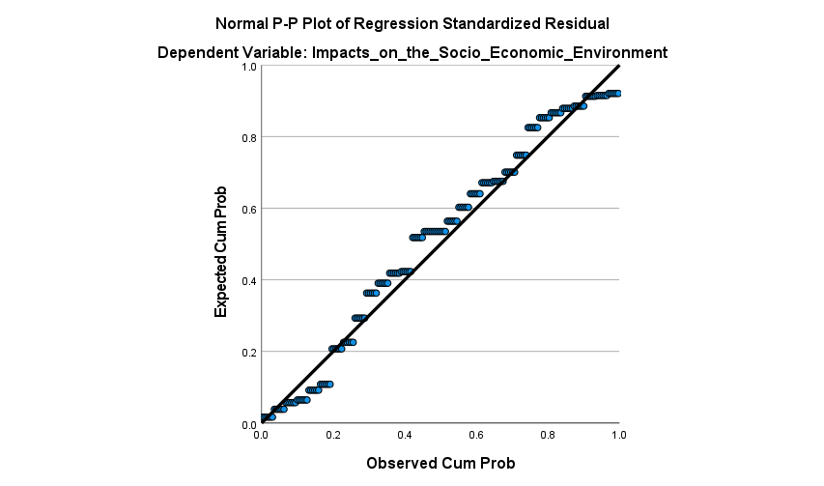

Figure 4.1: Normal P–P Plot of Regression Standardized Residuals for the Dependent Variable "Impacts on the Socio-Economic Environment
The Normal P-P Plot of Regression Standardized Residuals for the model assessing the impact of stone quarrying activities on the socio-economic environment provides valuable insight into the assumption of normality in regression analysis. In this diagnostic tool, the cumulative probabilities observed of the standardized residuals are plotted against the expected cumulative probabilities from a normal distribution. A strong indication of normality is when these points fall closely along the 45-degree diagonal line running from the lower left to the upper right corner of the plot. In this case, the points are well-aligned along the diagonal, with no substantial deviations or visible patterns straying from the reference line. This alignment indicates that the residuals of the regression model are approximately normally distributed, which fulfils one of the key assumptions underlying linear regression analysis. Meeting this assumption enhances the reliability of hypothesis testing and confidence interval estimates derived from the model. As Field (2020) emphasizes, confirming the normality of residuals ensures the robustness of regression results and protects against misleading inferences. Consequently, the results from this analysis, including the identified significant relationship between stone quarrying activities and socio-economic impacts, can be considered statistically sound and valid for policy and academic interpretation.
Table 4.11: Chi-Square Tests
 | Value | df | Asymptotic Significance (2-sided)
Pearson Chi-Square | 1613.292ª | 270 | .000
Likelihood Ratio | 763.618 | 270 | .000
Linear-by-Linear Association | 84.194 | 1 | .000
N of Valid Cases | 186
a. 304 cells (100.0%) have expected count less than 5. The minimum expected count is .19.
Source: Author, 2025
The Chi-Square test results demonstrated a statistically significant relationship between the variables analysed, presumably quarrying activities and socio-economic. The Pearson Chi-Square value was 1613.292 with 270 degrees of freedom, and the associated p-value was .000, indicating a highly significant result at the 0.05 level. Similarly, the Likelihood Ratio also yielded a statistically significant result with a p-value of .000, and the Linear-by-Linear Association showed a significant value of 84.194 with a p-value of .000. These findings suggest that the variables under consideration were not independent and that quarrying activities had a statistically significant association with changes in the environment and/or socio-economic conditions of residents in Kajiado East Sub-County. However, despite the strong statistical significance, the reliability of these findings is severely limited by a major methodological issue: all 304 cells (100%) had expected counts less than 5, with the minimum expected count being 0.19. This violates a critical assumption of the Chi-Square test, which requires most expected frequencies to be 5 or more to ensure valid results. The small, expected cell counts inflate the test statistic, potentially leading to misleading conclusions. Therefore, while the results suggest a significant relationship, they must be interpreted with caution. Alternative statistical approaches, such as Fisher’s Exact Test, category merging, or logistic regression, should be considered to validate these findings under more appropriate conditions.
Summary of Land Cover Classification Accuracy (1993–2023)
Table 4.12 presents the User Accuracy and Producer Accuracy percentages for various land cover classes, Grassland, Shrubland, Forest, Built-Up, Water, Bare Land, and Cropland, across four temporal intervals (1993, 2003, 2013, and 2023). It also includes overall classification accuracy and Kappa coefficients for each year, reflecting the consistency and reliability of the land cover classification process.

Table 4.14: User and Producer Accuracy of Land Cover Classification for 1993, 2003, 2013, and 2023
Year | 1993 |  | 2003 |  | 2013 |  | 2023
 | User Accuracy (%) | Producer Accuracy (%) | User Accuracy (%) | Producer Accuracy (%) | User Accuracy (%) | Producer Accuracy (%) | User Accuracy (%) | Producer Accuracy (%)
Grassland | 87.88 | 87.88 | 90.48 | 88.37 | 90.57 | 87.27 | 87.00 | 94.00
Shrub land | 92.31 | 83.72 | 90.32 | 80.00 | 78.95 | 62.50 | 87.00 | 57.00
Forest | 84.62 | 78.57 | 80.00 | 88.89 | 80.00 | 88.89 | 80.00 | 80.00
Built Up | 80.00 | 100.00 | 80.00 | 88.89 | 90.00 | 100.00 | 80.00 | 100.00
Water | 100.00 | 100.00 | 70.00 | 100.00 | 100.00 | 90.91 | 90.00 | 100.00
Bare land | 80.00 | 80.00 | 75.00 | 100.00 | 69.23 | 100.00 | 87.00 | 81.00
Cropland | 70.00 | 100.00 | 80.00 | 61.54 | 80.00 | 100.00 | 80.00 | 100.00
Kappa | 87.20 |  | 84.80 |  | 86.60 |  | 86.00
Accuracy | 83.78 |  | 80.61 |  | 80.87 |  | 81.07
Source: Author, 2025
The land cover classification across the four periods (1993, 2003, 2013, and 2023) exhibited generally acceptable levels of accuracy, with overall classification accuracy values ranging from 80.61% (2003) to 83.78% (1993), and Kappa coefficients ranging between 84.80 and 87.20, indicating strong agreement between classified data and ground truth. Grassland and Shrubland, being dominant land cover types in rangeland ecosystems, maintained high user and producer accuracy across the years. Grassland demonstrated stable user accuracy (~87–91%) and improved producer accuracy, peaking at 94% in 2023, indicating better identification and delineation over time. Shrubland, however, displayed a declining trend in producer accuracy, from 83.72% (1993) to 57% (2023), suggesting increasing misclassification or spectral confusion, possibly due to land degradation or vegetation fragmentation. The forest class showed relatively stable accuracy across all periods, with both UA and PA values consistently ranging from 80% to 89%, which supports moderate confidence in forest mapping and monitoring. Built-up areas achieved perfect producer accuracy in 1993, 2013, and 2023 (100%), indicating consistent detection of urban features, though user accuracy fluctuated, likely due to overlaps with bare land or croplands. Water bodies consistently maintained high producer accuracy (100% in all years except 2013), though user accuracy varied, dipping in 2003 (70%) and recovering by 2023 (90%), indicating occasional over-classification of non-water pixels as water. Bare land and cropland showed varied accuracies. Bare land producer accuracy remained high (mostly 100%), while user accuracy ranged from 69.23% to 87%, suggesting occasional confusion with built-up areas or fallow lands. Cropland producer accuracy was highest in 1993 and 2013 (100%) and remained high in 2023, though user accuracy remained moderate at 70–80%, reflecting spectral overlap with grasslands or shrublands during non-growing seasons. The classification results are robust and suitable for change detection and temporal analysis. The consistent kappa scores (above 84%) and overall accuracies (above 80%) validate the reliability of NDVI and LULC analyses used in the study to track vegetation dynamics under the influence of conservancies. The sharp drop in shrubland producer accuracy over time may reflect land cover transformations linked to intensified grazing, encroachment, or climate variability, thus supporting insights into ecological pressures and potential degradation within the rangelands.
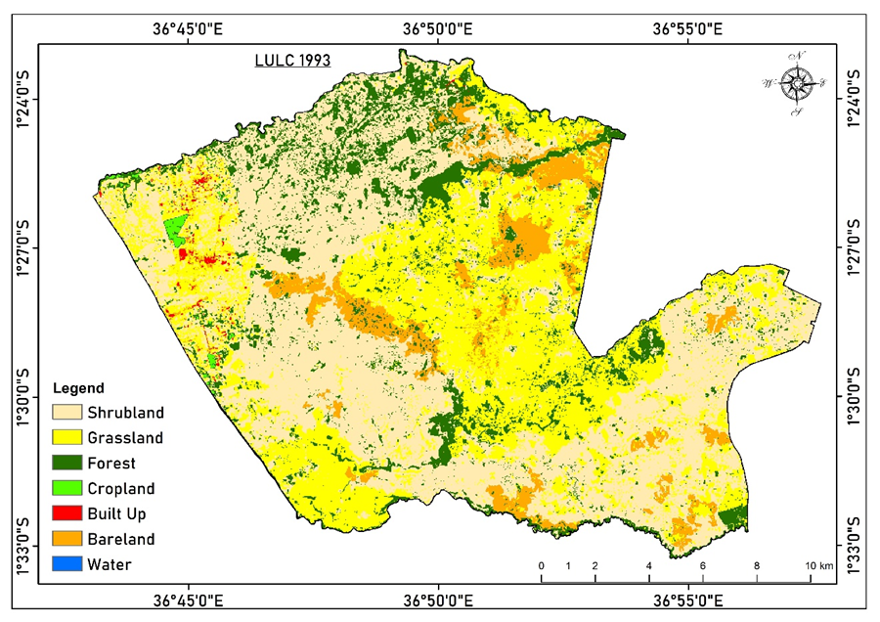

Figure 4.2: Land Use Land Cover (LULC) Map for the Year 1993.
The map illustrates the spatial distribution of various land cover types within the study area, classified into shrubland, grassland, forest, cropland, built-up areas, bare land, and water bodies. The legend provides corresponding color codes for each land cover class, while the map includes geographic coordinates and a scale bar for spatial reference.
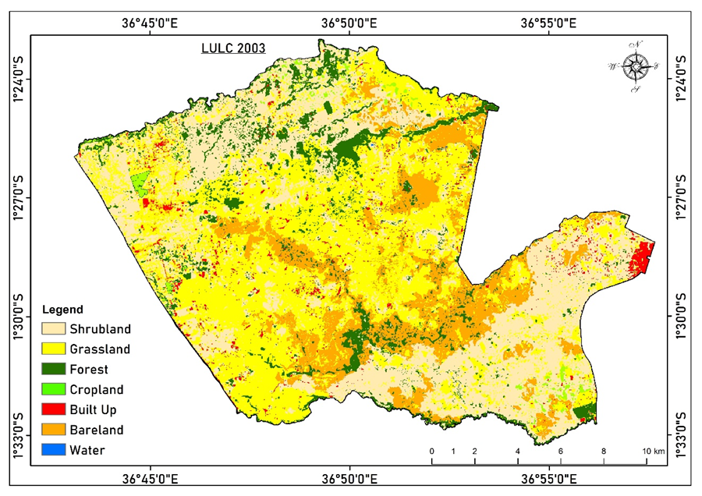

Figure 4.3: Land Use/Land Cover (LULC) map of the study area in 2003,
Figure 4.3: Land Use/Land Cover (LULC) map of the study area in 2003, illustrating changes in the extent and distribution of various land cover classes over a 10-year period, with noticeable increases in built-up areas and cropland.
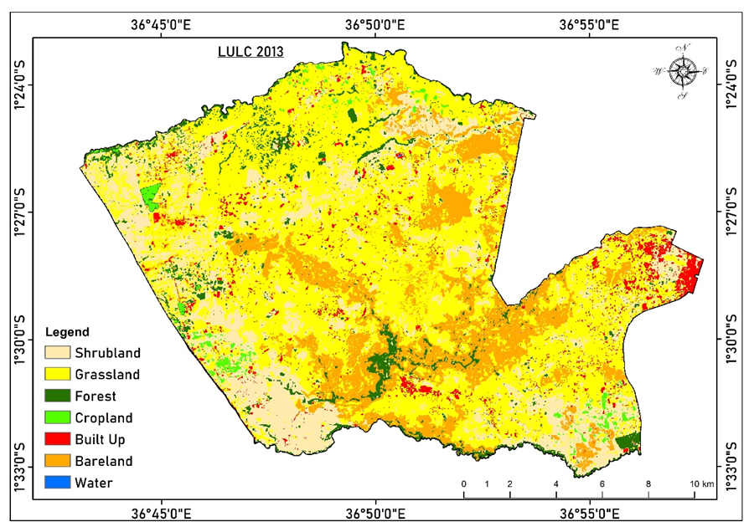

Figure 4.4: Land Use/Land Cover (LULC) map of the study area in 2013
Figure 4.4: Land Use/Land Cover (LULC) map of the study area in 2013, presenting further changes in land cover distribution over a 20-year period. The map reveals continued expansion of built-up areas, an increase in cropland, and a reduction in forest cover and shrubland, reflecting ongoing anthropogenic land use transformations.
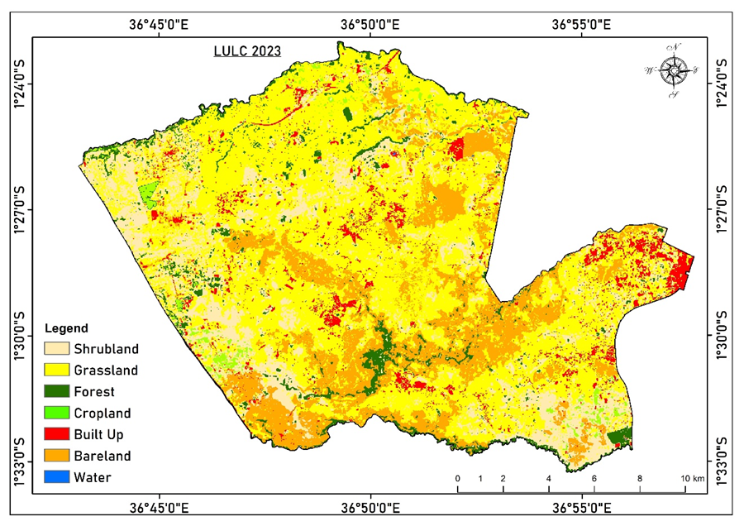

Figure 4.5: Land Use/Land Cover (LULC) map of the study area in 2023

Figure 4.5: Land Use/Land Cover (LULC) map of the study area in 2023, presenting further changes in land cover distribution over a 20-year period. The map reveals the continued expansion of built-up areas, an increase in cropland, and a reduction in forest cover and shrubland, reflecting ongoing anthropogenic land-use transformations.
These land cover changes in Kajiado East Sub-County is driven by factors such as population growth, urbanisation, agricultural expansion, and climate variability. From the analysis, we note that bare land, Built-up Areas, Cropland, and grassland have increased from 1993 to 2023, while Forest, shrubland, and water have decreased over the same period. Bare land has increased from 7.49% to 17.25%, Built up, increased from 0.35% to 5.16%, cropland from 0.29% to 1.26% and grassland from 32.66% to 53.96%. Meanwhile, forest cover has decreased from 12.92% to 4.55%, shrubland from 46.29% to 17.81%, and water has remained fairly unchanged over time. There has been an upward increase in buildup. The area is experiencing urban growth, a growing population, and low land prices within the satellite towns (Ongata Rongai, Athi River, Mlolongo and Tuala). The rapid urban development could also be related to good roads and connectivity between the satellite towns, along with closeness to Nairobi town, which attracts a high labour force but has minimal provision for residential services. Our results align with those of Munyoki et al. (2024), who found an increase in built-up areas in the Mbagathi catchment, which covers our study area. Furthermore, the area is experiencing a change in land tenure systems, from communal land to privatised group ranches, private-owned land, and protected areas.
Bare land has also been on the increase in our study area. This Can be attributed to urban expansion and land degradation. As noted, the area is experiencing high urban sprawl, a growing population, and the effects of climate change. This is confirmed by studies made by Munyoki et al. (2024), who, in their findings, attributed an increase in bare land from 10% to 38% between 1990 and 2020. This percentage indicates for the same period, bare land has tripled in size.
Review of research works by Munyoki et al (2024), indicates grassland has reduced over the same period. However, that did not account for the difference between grassland and shrub land. Our research, on the contrary, identified grassland as decreasing and shrubland as increasing. This can be attributed to the natural phenomenon of converting shrubland to grassland, either due to natural processes or external factors. Major causes of this change include overgrazing and livestock pressure (Sang et al., 2023); agricultural expansion (Syombua, 2013); and climate variability and drought (Ruttoh et al., 2022). Coupled together, there is a shift from shrubland to grassland in our study area. Forest cover has been on the decline from 1993 to the present. The major forest cover is located within Nairobi National Park, a protected area that has not been significantly affected. However, the forest cover outside the park has been cleared due to anthropogenic activities. Our analysis aligns with Munyoki et al. (2024), which results in a decrease in forest cover. The area has also seen an increase in cropland activities, both rainfed and irrigated crops. This occurs south of Nairobi National Park and toward private ranches near Kisaju (Kerubo 2016). There has been no research focusing on cropland in the study area; however, with the increase in population and urbanisation, there is a need for agricultural produce. This serves as a trigger to the emergence and growth of cropland.
Land Use and Land Cover (LULC) Dynamics in Kajiado East Sub-County (1993–2023)
This table illustrates the changes in Land Use and Land Cover (LULC) across four reference years, 1993, 2003, 2013, and 2023, within a study area of 287.14 km².

Table 4.15: Land Use Land Cover (LULC) Changes from 1993 to 2023
LULC | 1993 |  | 2003 |  | 2013 |  | 2023
 | sq km | % | sq km | % | sq km | % | sq km | %
Shrubland | 132.93 | 46.29 | 97.12 | 33.82 | 65.44 | 22.79 | 51.13 | 17.81
Grassland | 93.78 | 32.66 | 114.00 | 39.70 | 150.10 | 52.27 | 154.95 | 53.96
Forest | 37.09 | 12.92 | 24.89 | 8.67 | 14.04 | 4.89 | 13.08 | 4.55
Bare land | 21.49 | 7.49 | 42.26 | 14.72 | 43.10 | 15.01 | 49.52 | 17.25
Cropland | 0.85 | 0.29 | 2.58 | 0.90 | 3.24 | 1.13 | 3.63 | 1.26
Built Up | 0.99 | 0.35 | 6.28 | 2.19 | 11.21 | 3.90 | 14.82 | 5.16
Water | 0.02 | 0.01 | 0.02 | 0.01 | 0.02 | 0.01 | 0.02 | 0.01
Total | 287.14 | 100.00 | 287.14 | 100.00 | 287.14 | 100.00 | 287.14 | 100.00
Source: Author, 2025
Over the 30 years from 1993 to 2023, Kajiado East Sub-County underwent notable land use and land cover (LULC) changes, significantly affecting vegetation cover and ecosystem health. The most prominent positive change was in grassland, which increased from 93.78 km² (32.66%) in 1993 to 154.95 km² (53.96%) in 2023, indicating a 65.2% rise. This trend suggests that interventions such as regulated grazing, community-based conservancy management, and pasture regeneration efforts, including tree nursery initiatives, have contributed positively to rangeland restoration. The growth in grasslands reflects improved ecosystem health, with potentially enhanced forage availability, reduced erosion, and better microclimatic conditions that support pastoral resilience. Conversely, shrubland sharply declined from 132.93 km² (46.29%) to 51.13 km² (17.81%), marking a 61.5% loss, which may signal vegetation degradation due to over-browsing, drought stress, or bush-to-grassland conversion resulting from shifting land use practices within conservancy zones. While this reduction could indicate successful reclamation and thinning of invasive shrubs to promote pasture growth, it may also imply ecological simplification, which could impact biodiversity. Forest cover decreased from 37.09 km² (12.92%) to 13.08 km² (4.55%), a 64.7% decline, suggesting the continuing pressures from human settlement, firewood collection, or lack of reforestation programs in non-protected areas. This degradation highlights a critical gap in conservation management, where tree nursery projects and agroforestry interventions remain inadequate or insufficiently scaled despite their importance for long-term ecosystem services, such as carbon sequestration, rainfall retention, and biodiversity support.
In contrast, bare land expanded from 21.49 km² (7.49%) to 49.52 km² (17.25%), indicating clear environmental stress, including land degradation, desertification, and soil compaction caused by overgrazing, reduced vegetative cover, and prolonged dry spells. This increase is ecologically alarming, as it implies declining productivity and possible shifts toward irreversible land degradation without targeted interventions. Other changes include a moderate increase in cropland (from 0.85 km² to 3.63 km²) and a significant rise in built-up areas (from 0.99 km² to 14.82 km²), reflecting demographic growth and infrastructural expansion, especially around conservancy areas. While these changes may improve livelihoods through diversification, they also exert pressure on land use, contributing to the fragmentation of grazing areas and increased runoff, as well as habitat disruption. Notably, water bodies remained unchanged, highlighting the persistent water scarcity that is a key ecological challenge in semi-arid zones like Kajiado East. While modern conservancies and related greening initiatives, such as tree nursery projects, have contributed positively to grassland recovery in Kajiado East, the concurrent loss of forest cover and expansion of bare land and settlements underscore the fragile balance between conservation and development. The study recommends enhanced investment in reforestation, drought-resilient vegetation, rotational grazing, and water harvesting systems to reinforce ecosystem stability, alongside participatory monitoring to ensure that conservancy goals align with sustainable land management in Kenya’s drylands.
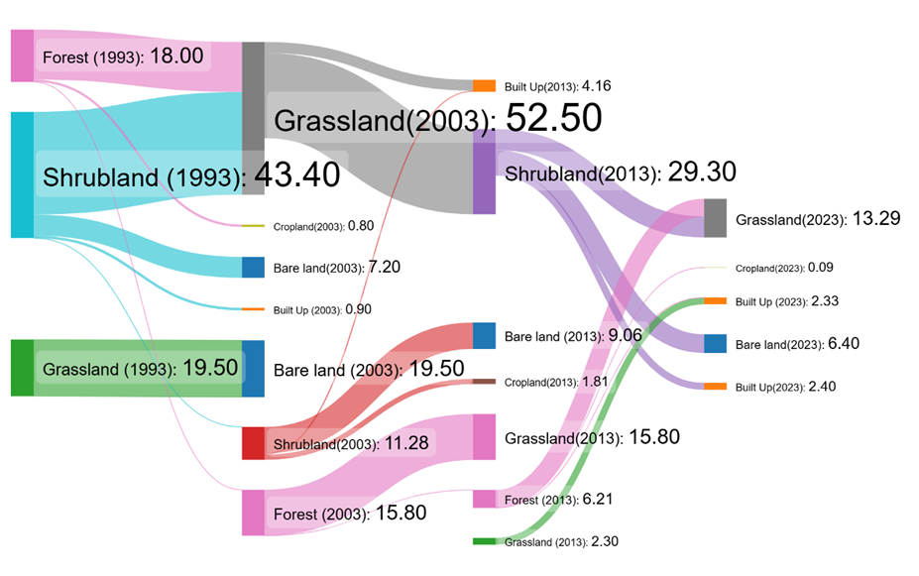

Figure 4.6: Sankey Diagram
Figure 4.6: Sankey Diagram illustrates the transitions in land cover types over a 30-year period from 1993 to 2023. The diagram highlights significant changes in major land cover categories such as forest, shrubland, grassland, bare land, cropland, and built-up areas. In 1993, Shrubland was the most dominant land cover at 43.40, followed by forest (18.00) and grassland (19.50). By 2003, grassland had increased significantly to 52.50, largely due to conversions from shrubland and forest. However, both grassland and shrubland showed a decline in later years, with shrubland dropping to 29.30 by 2013 and grassland reducing to 13.29 by 2023. Forest cover also declined steadily over the years, from 18.00 in 1993 to just 6.21 in 2013. Meanwhile, built-up areas increased consistently, indicating urban expansion, growing from 0.90 in 2003 to a combined 4.73 in 2023. The diagram reflects a clear trend of natural land covers being converted to urban or degraded land uses over time.
Land degradation
Apart from the LULC transitions in the area, land degradation over the same period (1993–2023) indicates the impacts of quarrying activity on the environment. This is in line with SDG 15 (life on land), which aims “to combat desertification, restore degraded land and soil, including land affected by desertification, drought and floods, and strive to achieve a land degradation-neutral world” by 2030. The United Nations Convention to Combat Desertification (UNCCD), guided by good practice, has identified three sub-indicators for determining land degradation: productivity, land cover, and soil organic carbon. Productivity is the biological productive capacity of the land (the source of all the food, fiber and fuel that sustains humans) and is estimated from the analysis of the Normalized Difference Vegetation Index (NDVI). Changes in land productivity indicate long-term shifts in the health and productive capacity of the land, reflecting the net effects of changes in ecosystem functioning on plant and biomass growth. This assessment includes only above-ground productivity and can be applied to all natural and anthropogenic terrestrial environments. Land cover, as defined by UNCCD, is the observed physical cover of the earth’s surface and provides the first indication of a reduction or increase in vegetation, habitat fragmentation and land conversion. Carbon stock is the amount of carbon in a pool. A pool is defined as a system that can accumulate or release carbon and include biomass (above-ground and below-ground biomass; dead organic matter (deadwood and litter); and soil (soil organic matter).
Land degradation was analysed based on the baseline assessment and evaluation of three sub-indicators: land productivity, land cover, and soil organic carbon (UNCCD, 2005). Land degradation is determined by assessing the changes in the three sub-indicators, which are depicted as positive (improving), stable or unchanging, and negative (declining). Land productivity was calculated from the NDVI dataset from Modis (MOD13Q1, annual) satellite. The soil organic carbon was evaluated using the inbuilt soil dataset o from the International Soil Reference and Information Centre (ISRIC) (https://www.isric.org). The land cover datasets produced during this study were uploaded into the platform and used to evaluate the land cover sub-indicator. The three sub-indicators were computed on a cloud-based Google Earth Engine platform linked to the QGIS Trends. Earth Plugin to produce the degradation status of the watershed. The land is considered degraded if there is a significant reduction or negative change in any one of the three sub-indicators. The results are presented in percentages (the proportion of land that is degraded over the total land area). Our analysis indicates that the area around the quarry (circled in blue) in the figure below shows it has undergone degradation, while the area nearby has remained relatively stable. This indicates quarrying activity has hampered the natural ability of the land surface to improve. See the figure 4.7 below, label it and refer to it in the text.
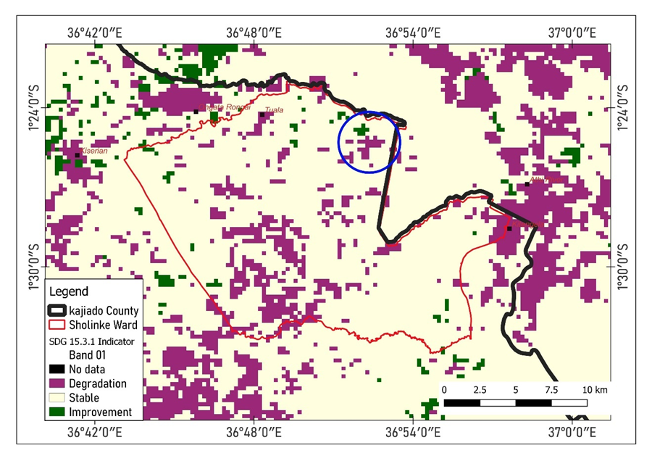

Figure 4.7: Land Degradation Status in Sholinke Ward, Kajiado County

The map illustrates the spatial distribution of land degradation based on the SDG 15.3.1 Indicator within Sholinke Ward in Kajiado County. The ward boundary is outlined in red, while the black boundary denotes Kajiado County. The land condition is categorized into four classes: Degradation (purple), Stable (cream), Improvement (green), and No data (black). A significant portion of the area, particularly in the central and eastern parts of the ward, shows evidence of degradation. Patches of stable land dominate the northern and southern zones, while scattered improvements in land conditions are observed primarily in small clusters across the ward. The presence of vast degraded zones indicates pressure on natural resources, likely from overgrazing, settlement expansion, or unsustainable land use practices. This spatial analysis is essential for identifying priority areas for land restoration and sustainable land management interventions.

CHAPTER FIVE

DISCUSSIONS, CONCLUSIONS AND RECOMMENDATIONS

5.1 Introduction
This chapter presents a comprehensive discussion of the study findings in relation to existing literature and the specific objectives of the study, which focuses on assessing the effects of quarrying activities on sustainable environmental management in Kajiado East Sub-County. The discussion integrates both biophysical and socio-economic dimensions, as well as the effectiveness of policy, legal, and institutional frameworks governing quarry operations. It aligns the findings with prior research, highlighting areas of convergence and divergence, and provides evidence-based conclusions drawn from both descriptive and inferential analyses. Furthermore, the chapter identifies the implications of quarrying on land degradation, biodiversity, water resources, livelihoods, and governance. It also provides practical recommendations designed to enhance sustainable quarry management, strengthen institutional coordination, and promote community participation. The discussion provides a basis for informed policymaking and suggests areas for further research.

5.2. Discussions
The section details the discussions about the study's outcomes, organised according to the themes guiding the study.

5.2.1. Stone Quarrying Activities and Sustainable Environmental Management
The performance of tree nursery projects in the mountain region illustrates a dynamic interplay between environmental degradation and recovery, a theme that resonates with the findings on stone quarrying in Kajiado East Sub-County. The analysis revealed that stone quarrying activities have significant implications for sustainable environmental management, particularly concerning land, soil, biodiversity, and water quality. A composite mean score of 3.682 and a standard deviation of 0.934 across 14 indicators revealed moderate agreement among respondents that quarrying contributes to land degradation, alters topography, and has a negative impact on flora, fauna, and water systems. Specifically, the highest mean scores were recorded for biodiversity conservation efforts (M = 4.097) and negative impacts on plant species (M = 4.097), suggesting that the community perceives environmental consequences as significant and far-reaching. These findings align with those of Lalonde et al. (2023), who emphasised that extractive industries, including stone quarrying, disrupt native ecosystems and facilitate the proliferation of invasive species. This finding is corroborated by Thompson (2022), who also reported similar negative impacts on vegetation and biodiversity across East African quarrying regions. Notably, reclamation efforts also emerged as a prominent theme. Respondents reported moderate satisfaction with land restoration measures (M = 3.806), suggesting that while reclamation is ongoing, it may not yet be fully effective or evenly implemented. This perception is supported by Kariuki (2021), who noted that while reclamation plans are often included in quarrying operations, execution is frequently inconsistent due to funding gaps and weak enforcement mechanisms. Furthermore, the community noted that quarrying activities affected water resources, with responses indicating concern over groundwater depletion (M = 3.45), water diversion (M = 3.16), and water pollution (M = 3.45). These outcomes underscore the environmental footprint of quarrying and align with Ngugi et al. (2022), who identified water stress as a critical challenge in quarry-intensive sub-counties in Kenya. Conversely, the study's inferential analysis revealed no statistically significant correlation between quarrying activities and the NDVI (Normalised Difference Vegetation Index), with a correlation coefficient of r = -0.003 and a p-value of 0.973. Similarly, regression analysis indicated that quarrying activities had negligible predictive power on NDVI (R² = .000). These results contradict earlier findings by Smith et al. (2022) and Mwangi et al. (2023), who observed negative correlations between quarrying and vegetative health using NDVI in other regions. The discrepancy may arise from temporal lags in vegetation loss, spatial limitations of satellite data, or the presence of ongoing reclamation efforts in the study area, which may have stabilized NDVI values. As such, while community perception highlights evident biophysical degradation, remotely sensed data may not yet capture these effects due to scale and timing discrepancies. Ultimately, the findings underscore the need for integrated, site-specific environmental assessments and improved monitoring systems that go beyond satellite-based NDVI to include ground truthing and local ecological indicators. The evidence supports calls by UNEP (2020) and Mwangi et al. (2021) for stronger environmental governance and the adoption of sustainability principles in quarry management. This includes ensuring active and effective reclamation, stringent enforcement of environmental impact assessments (EIAs), and broader participation of local communities in environmental decision-making. By adopting a multi-pronged approach that incorporates both technological and participatory tools, stakeholders can enhance the environmental sustainability of quarrying operations in Kenya and similar settings.
Quarrying activities have profound and often irreversible impacts on land use and land cover (LULC) over time, influencing both the physical landscape and the socio-environmental dynamics of the affected regions. The process typically begins with the clearing of vegetation and the removal of topsoil to access underlying mineral resources. This initial phase leads to a rapid and extensive loss of natural vegetation cover, disrupting local ecosystems and reducing biodiversity (Aigbedion & Iyayi, 2007). Forested areas, shrublands, and grasslands are frequently converted into bare land, excavation pits, or waste dump sites, marking a stark shift in land cover classes when analyzed through temporal remote sensing data, as noted by the steady increase in bare land from 1993 to 2023. Additionally, the results indicated a decrease in shrubland over the same period. This vegetation loss not only contributes to habitat destruction but also reduces the landscape's carbon sequestration potential, thereby exacerbating local and regional climate variability.
The physical disturbance caused by quarrying also results in significant soil erosion and land degradation. The removal of protective vegetation and topsoil destabilizes the ground surface, making it highly susceptible to wind and water erosion. This leads to sedimentation in nearby rivers and streams, the formation of gullies, and a decline in overall land productivity (Lameed & Ayodele, 2010). In many cases, such degraded land becomes unsuitable for future agricultural use or settlement, further altering land use potential and intensifying competition for arable land. In regions where land is already under pressure due to population growth and urbanization, this can have serious implications for food security and rural livelihoods.
Beyond the immediate area of extraction, quarrying often induces indirect changes in land use patterns. As extraction activities expand, they can encroach on surrounding agricultural lands or protected natural areas, leading to a gradual conversion of land from rural or ecological uses to industrial purposes (Samimi & Aghdam, 2011). This transformation is often accompanied by the development of access roads, storage facilities, and temporary worker settlements, which contribute to the fragmentation of landscapes and complicate land management further. Moreover, the pollution associated with quarrying, including dust emissions, noise, and water contamination, can degrade nearby ecosystems and reduce the suitability of the land for other purposes.
In peri-urban and rapidly developing areas, quarrying can also catalyze unplanned urban sprawl. As quarry sites attract labor and investment, they may stimulate the growth of informal settlements in their vicinity. Over time, these areas may evolve into densely populated zones lacking proper infrastructure or planning, resulting in further land use transformations and increased environmental pressures. Ngurunga Quarry, which has grown over time from 0.13 sq km to 1.23 sq km, has greatly influenced urban growth in the Tuala area, Mlolongo, Ongata Rongai, Kitengela, Athi River, and other nearby areas. This collaborates with research by Shrestha, (2010). The expansion of such settlements often occurs at the expense of agricultural or conservation land, creating complex challenges for land use planning authorities.
Importantly, the long-term legacy of quarrying includes the persistence of abandoned or poorly rehabilitated sites. These sites often remain as barren, unvegetated land or flooded pits, which are easily identifiable in satellite imagery and LULC classification studies. Without proper reclamation, such landscapes become ecological and visual scars that offer limited functionality for agriculture, habitation, or natural regeneration (Durucan et al., 2006). The cumulative effects of these transformations underscore the urgent need for integrated land use planning, effective regulatory enforcement, and post-extraction land rehabilitation to ensure the sustainable management of land resources in quarrying regions.
Land degradation resulting from quarrying activity is a significant environmental concern, particularly in areas where quarrying is poorly regulated or uncontrolled. The quarrying process, which involves the extraction of rocks, sand, gravel, and other minerals from the earth, often leads to the stripping away of topsoil and vegetation. This disturbance alters the natural landscape, exposing the land to erosion and reducing its fertility and long-term productivity. The removal of vegetation cover not only affects the soil structure but also destroys habitats, leading to a decline in biodiversity. As quarry sites expand, they frequently encroach on agricultural land and forests, further intensifying environmental damage.
Socially and economically, quarrying-induced land degradation can have long-term consequences. It diminishes the land’s potential for agriculture, reduces local livelihood options, and contributes to the marginalization of rural populations. Land conflicts may arise when communities feel displaced or deprived of access to natural resources. To mitigate these impacts, sustainable quarrying practices must be implemented.

5.2.2. Socio-Economic Environment and Sustainable Environmental Management
The performance of tree nursery projects in the mountain region has demonstrated that socio-economic benefits can coexist with environmental degradation if not managed sustainably. This reality is mirrored in Kajiado East Sub-County, where stone quarrying exerts a complex influence on socio-economic dynamics. The descriptive findings revealed that quarrying has both enhanced and strained local livelihoods, with a composite mean of 3.948 and standard deviation of 0.831, indicating overall moderate to strong agreement across socio-economic indicators. Participants strongly affirmed that quarrying created employment (M = 4.00), improved household income (M = 3.87), and increased markets and services (M = 3.93). These results are consistent with those of Mwangi et al. (2022), who found that quarrying contributes significantly to rural employment and income diversification, especially in regions with limited formal job opportunities. However, the analysis also uncovered significant adverse effects. Respondents agreed that quarrying has led to economic challenges such as loss of farmland (M = 4.065) and increased conflict or displacement (M = 3.677). Similarly, infrastructure development received mixed feedback (M = 3.484), indicating disparities in the distribution of benefits. This finding resonates with Njoroge et al. (2022), who documented unequal infrastructure improvements concentrated near quarry sites. Furthermore, health-related concerns were prominent, with participants reporting quarrying-induced illnesses (M = 4.194) and safety risks (M = 4.194). Kariuki (2023) attributes such effects to dust inhalation, machinery accidents, and environmental pollution—common in unregulated quarry environments. The regression analysis revealed a strong positive correlation between stone quarrying activities and socio-economic impacts, with R² = 0.455 and β = 0.675 (p < .001), indicating that approximately 45.5% of the variance in socio-economic outcomes is explained by quarrying activities. This finding aligns with Chege and Wambua (2023), who emphasised that while quarrying stimulates local economies, it introduces significant vulnerabilities, particularly in terms of health, land security, and social cohesion. Moreover, Mutua and Mwanzia (2022) caution that socio-economic gains from quarrying are often temporary and unsustainable unless accompanied by proactive governance and equitable benefit-sharing mechanisms. Interestingly, participants perceived local health facilities as adequate to handle quarry-related issues (M = 4.129), suggesting either improved access or high tolerance levels. Yet, low variability (CV = 16.01%) implies uniformity in experience, which may mask latent inefficiencies or overburdening of facilities during peak operations (Oloo et al., 2022). Finally, while a majority viewed quarrying as broadly beneficial (M = 4.032), the coexistence of benefits with displacement, health hazards, and infrastructure disparities underlines the dualistic nature of quarrying’s socio-economic footprint. In conclusion, sustainable environmental management in quarry zones must prioritize community-based approaches that integrate livelihood enhancement with environmental and health safeguards. Key policy recommendations include mandatory social impact assessments, community benefit-sharing agreements, and strengthened occupational safety protocols. These measures will ensure that the economic gains from quarrying are inclusive sustainable, and do not compromise the social fabric of affected communities.

5.2.3. Policy, Legal, and Institutional Framework and Sustainable Environmental Management
Sustainable environmental management is fundamentally anchored on sound governance frameworks, effective institutional coordination, and meaningful community participation, critical enablers for responsible quarrying management. The findings of this study revealed a generally positive perception of existing policy, legal, and institutional arrangements governing quarrying activities in Kajiado East Sub-County. With a composite mean of 3.968 and a standard deviation of 0.836, respondents moderately agreed on the relevance and adequacy of these frameworks. Participants expressed strong awareness of quarrying policies (M = 4.000) and perceived legal frameworks as adequate (M = 4.032), aligning with Kariuki (2024), who observed that Kenya’s mining laws have progressively incorporated environmental safeguards, reclamation obligations, and stakeholder engagement protocols.
Interestingly, quarry operator compliance was also rated favorably (M = 4.129), echoing Njoroge et al. (2023), who noted rising adherence to environmental regulations, partially attributed to enhanced institutional accountability and increased public scrutiny. However, a critical governance challenge emerged in the form of weak inter-institutional coordination (M = 3.935; CV = 25.85%), signaling inconsistency in operational linkages between regulators such as NEMA, county authorities, and law enforcement agencies. This corroborates Mwangi et al. (2023), who argued that overlapping mandates, underfunding, and poor interagency communication often undermine environmental oversight in decentralized jurisdictions.
Moreover, respondents identified capacity limitations, inadequate funding, and political interference as persistent obstacles facing regulatory institutions (M = 3.710; CV = 28.47%). These systemic weaknesses mirror Mutua et al. (2023)’s assertion that while Kenya’s environmental legal framework is robust on paper, its enforcement capacity remains fragile, especially in rural and peri-urban settings where extractive industries flourish with minimal oversight.
On community participation, findings reflected a relatively strong perception (M = 4.00) regarding opportunities for public involvement in quarrying governance. Nonetheless, the moderate variability in responses (CV = 21.12%) suggests unequal experiences of inclusion. This finding is consistent with Mutua et al. (2022), who cautioned that although participatory governance structures exist, marginalised groups, particularly women and pastoral communities, often remain excluded from critical decision-making forums. Effective, inclusive participation remains a priority area for democratic, sustainable resource management.
Notably, inferential analysis revealed no statistically significant relationship between policy and institutional frameworks and NDVI of vegetation cover (r = -0.006, p = .939). This disconnect implies that while awareness and perceptions of governance structures are strong, they have not yet translated into measurable ecological improvements. This finding diverges from international studies (e.g., Smith et al., 2022), which documented positive correlations between stringent policy enforcement and environmental recovery. The discrepancy could reflect delayed ecological responses, limited enforcement scale, or structural constraints inhibiting policy outcomes. Strengthening institutional capacity, closing coordination gaps, and fostering meaningful, inclusive community engagement remain critical policy imperatives for sustainable quarrying governance in Kajiado East.
The findings from this study underscore the need for a strategic reorientation of quarry governance frameworks in Kajiado East Sub-County toward more effective, coordinated, and participatory environmental management. While existing policies and legal instruments are perceived as adequate, their limited translation into measurable ecological outcomes, as evidenced by the insignificant relationship with NDVI values, highlights a critical policy-practice gap. County governments, in collaboration with national agencies such as NEMA, should prioritize strengthening institutional capacities through increased budgetary allocations, targeted staff training, and the establishment of inter-agency coordination platforms to harmonize quarry regulation. Furthermore, the high variability in perceptions of institutional coordination and community participation signals the necessity for more inclusive, equitable governance structures. Specific policy reforms should formalize community representation, particularly for marginalised groups, in quarry licensing, environmental monitoring, and reclamation planning processes. Additionally, there is a need to operationalize existing participatory frameworks to move beyond symbolic inclusion toward meaningful involvement in decision-making. To support adaptive governance, integrating real-time remote sensing data into routine quarry monitoring would improve the responsiveness and accountability of enforcement agencies. Collectively, these interventions would enhance the effectiveness of legal frameworks, foster social legitimacy, and promote environmentally sustainable quarrying practices in the region.

5.2.4. Proposed Sustainable Quarry Management Model for Kajiado East Sub-County
In response to the gaps identified in the policy, legal, and institutional frameworks regulating stone quarrying activities, and informed by both empirical findings and conceptual frameworks on sustainable environmental management (Kariuki, 2024; Mutua et al., 2023; Smith et al., 2022), this study proposes a Sustainable Quarry Management Model (SQMM) for Kajiado East Sub-County. The model is designed to enhance coordination, accountability, ecological restoration, and community involvement within quarry governance structures.
The proposed SQMM integrates four interlinked pillars:
- Institutional coordination and capacity strengthening: Findings indicated poor inter-agency coordination and under-resourced regulatory institutions. The model recommends establishing a Quarry Environmental Management Coordination Committee (QEMCC) comprising NEMA, County Environment Departments, Sub-County Administrators, quarry operators, community representatives, and independent experts. The committee would harmonize quarry approval, monitoring, enforcement, and reclamation efforts, addressing overlapping mandates and operational gaps.
- Inclusive community participation framework: Recognizing the uneven experiences in community participation, the model proposes institutionalizing community quarry oversight boards at ward level, ensuring representation of women, youth, pastoralists, and quarry workers in decision-making, environmental monitoring, and benefit-sharing negotiations. This participatory approach aligns with Mutua et al. (2022)’s call for democratic natural resource governance and would enhance social legitimacy.
- Technological integration for environmental monitoring: To overcome data limitations and delayed ecological response detection, the model advocates integrating remote sensing and GIS technologies into routine environmental audits, using NDVI and other indices for real-time quarry footprint monitoring. This system would strengthen enforcement by providing objective, spatially explicit data for regulatory agencies and communities.
- Reclamation and land rehabilitation guidelines: Despite positive perceptions of policy awareness, ecological recovery was limited. The model recommends developing and enforcing mandatory quarry site reclamation plans, linked to quarry licensing processes. Operators would be obligated to rehabilitate exhausted sites through soil restoration, afforestation with native species, and conversion of select sites into community recreational or agricultural areas.
The Sustainable Quarry Management Model thus offers a holistic, locally adaptable framework addressing governance weaknesses, enhancing institutional coordination, promoting inclusive participation, and ensuring environmental sustainability in quarrying operations.

5.3. Summary of the findings
The findings are hereby summarized based on the research objectives.

5.3.1. Stone Quarrying Activities and Sustainable Environmental Management
The study found that stone quarrying activities had a significant impact on sustainable environmental management in Kajiado East Sub-County. Respondents reported visible signs of land degradation and changes in landforms caused by quarry operations. There was a general awareness of reclamation efforts, although views on their effectiveness varied, suggesting that some initiatives were either not fully implemented or did not yield the intended environmental outcomes. Participants reported that quarrying destroyed local plant life and biodiversity while also creating conditions that facilitated the spread of invasive species. These environmental disruptions extended to water sources, where residents observed increased pollution, reduced groundwater availability, and, in some instances, the destruction or diversion of water bodies. Air and noise pollution were also raised as concerns, particularly among residents living closer to quarry sites. While conservation efforts were acknowledged in some areas, their visibility and impact appeared inconsistent. Overall, the findings revealed that stone quarrying posed significant challenges to environmental sustainability, including soil degradation, biodiversity loss, and resource pollution. However, the study also indicated that some restoration practices had been initiated, although their reach and success required further enhancement. The results suggested a need for more coordinated environmental management strategies, community education, and long-term monitoring of ecological conditions to mitigate the negative consequences of quarrying and promote sustainable land use in the region.

5.3.2. Socio-Economic Environment and Sustainable Environmental Management
The study revealed that stone quarrying activities had both positive and negative socio-economic effects on local communities in Kajiado East Sub-County. Quarrying created employment opportunities and contributed to improved household incomes for many residents. Additionally, local markets and support services benefited from the increased economic activity associated with quarry operations. However, the study also found that quarrying displaced some community members, disrupted agricultural activities due to the loss of farmland, and contributed to social tensions and conflicts. Infrastructure development attributed to quarrying was reported as uneven, with some areas benefiting more than others. Health issues such as respiratory conditions and safety risks emerged as major concerns, particularly among individuals working in or living near the quarries. Despite these challenges, many respondents perceived quarrying as beneficial, largely due to its role in sustaining livelihoods. Health facilities were perceived as reasonably equipped to manage quarry-related health effects, although concerns persisted regarding long-term capacity and sustainability. The findings underscored that while quarrying had boosted local economic prospects, it also exposed communities to significant environmental and health vulnerabilities. The study emphasized the need for balanced development strategies that promote inclusive economic growth while safeguarding public health, land rights, and social cohesion. Strengthening occupational safety standards, improving infrastructure distribution, and ensuring transparent community engagement emerged as key areas for policy and programmatic improvement.

5.3.3. Policy, Legal, and Institutional Framework and Sustainable Environmental Management
The study found that most community members were aware of the existence of policy and legal frameworks regulating quarrying activities. Respondents generally viewed these regulations as adequate and believed that quarry operators complied with the requirements. However, institutional coordination among regulatory bodies was identified as a challenge, with respondents citing gaps in communication, overlapping responsibilities, and limited resource capacity. There were also concerns about political interference and underfunding, which affected the ability of institutions to enforce compliance effectively. Community participation in quarry-related decision-making was recognized, though its depth and impact varied across locations. While the governance structures appeared to be in place, their practical effectiveness in driving environmental outcomes remained questionable. The study revealed a disconnect between the perceived strength of regulatory frameworks and actual improvements in environmental sustainability. This suggested that although laws and policies were acknowledged, their implementation and enforcement had not consistently translated into visible ecological benefits. The findings highlighted the importance of building institutional capacity, enhancing inter-agency collaboration, and ensuring that community engagement was not merely symbolic but genuinely influential. Strengthening transparency, accountability, and resource allocation for regulatory institutions was deemed essential to ensure that quarrying activities were managed in a manner that upheld long-term environmental and community interests.

5.4. Conclusions
The study concluded that stone quarrying activities had significant adverse effects on sustainable environmental management in Kajiado East Sub-County. The operations contributed to land degradation, destruction of local vegetation, loss of biodiversity, and pollution of water and air resources. Although reclamation and conservation efforts were acknowledged, their effectiveness varied across locations, suggesting uneven implementation. The lack of a significant correlation between quarrying and NDVI measurements indicated that remote sensing data might not fully capture environmental degradation. Overall, while some environmental management practices were in place, they were insufficient to offset the negative ecological impacts of quarrying. Therefore, enhanced environmental monitoring, stricter enforcement of regulations, and improved reclamation strategies were necessary to promote sustainability and protect the region's ecological balance.
Furthermore, the study concluded that stone quarrying activities in Kajiado East Sub-Countyhabrought both socio-economic benefits and challenges. Quarrying generated employment, improved household incomes and stimulated local economic activities. However, these benefits were accompanied by adverse effects, including displacement, land loss, community conflict, and health risks. The regression analysis confirmed a strong relationship between quarrying and socio-economic change, indicating that the industry played a significant role in shaping local livelihoods. Despite perceived economic gains, uneven infrastructure development and safety concerns underscored the complexity of quarrying’s impact. The findings highlighted the need for inclusive planning and targeted interventions to maximize socio-economic benefits while addressing health, safety, and social equity concerns. A more balanced and participatory approach was essential for sustainable development in quarry-affected communities.
On policy, legal, and institutional framework and sustainable environmental management, it was concluded that while awareness of quarry-related policies and legal frameworks was high, the effectiveness of institutional coordination and enforcement remained limited. Respondents generally viewed existing laws as sufficient and believed that operators largely complied; however, inconsistencies in institutional collaboration and challenges such as underfunding and political interference weakened governance outcomes. Community involvement in decision-making was recognised, but its influence and depth varied. Despite a formal regulatory structure, practical implementation gaps persisted, limiting measurable environmental improvements. The absence of a clear link between regulatory measures and vegetation recovery further emphasized the need for stronger enforcement mechanisms. The study emphasized the importance of empowering regulatory institutions, improving inter-agency collaboration, and ensuring meaningful community participation to enhance the governance of quarrying and support sustainable environmental outcomes.

5.5. Recommendations from the Findings
Based on the study findings, several recommendations are proposed to promote sustainable environmental management in stone quarrying areas of Kajiado East Sub-County.
- Recommendation on Objective One – Effects on the Biophysical Environment:
Environmental restoration measures should be prioritized and institutionalized through mandatory reclamation plans for all quarry sites. This includes activities such as land levelling, soil stabilization, reforestation with indigenous tree species, and biodiversity rehabilitation. The National Environment Management Authority (NEMA) and the County Government should enforce strict compliance with Environmental Impact Assessments (EIAs) and Environmental Management Plans (EMPs), while enhancing post-extraction monitoring to mitigate adverse effects on land, vegetation, and water systems.
- Recommendation on Objective Two – Effects on the Socio-Economic Environment:
Benefit-sharing frameworks should be formalized to ensure that communities directly affected by quarrying activities gain tangible socio-economic benefits. Quarry operators must be compelled to contribute to community development through investments in infrastructure, health services, education, and alternative livelihood programs. Furthermore, they must guarantee occupational safety, fair compensation, and robust health and safety measures for both workers and the surrounding population.
- Recommendation on Objective Three – Effects of Policy, Legal, and Institutional Frameworks:
There is a critical need to enhance institutional capacity through increased funding, clear role definitions, and insulation from political interference. Regulatory institutions enforcement and oversight. Additionally, public participation mechanisms should be strengthened to involve local communities in planning, decision-making, and environmental monitoring, supported by regular awareness campaigns on legal rights and the impacts of quarrying.

5.6 Suggestions for Further Study
Future studies should explore the long-term ecological impacts of quarrying using longitudinal data and high-resolution remote sensing. Additionally, research could examine the effectiveness of specific reclamation techniques and community-based environmental governance models to identify best practices for sustainable quarry management in different ecological and socio-economic contexts across Kenya.

REFERENCE
Agnes Kasyoka Wambua, James Macharia Chege & Amos Mujema Ngira (2021) Bio-Physical and Socio-Economic Effects of Quarrying Activities in Selected Quarries in Tezo Ward-Kilifi County. International Journal of Environmental Sciences ISSN 2519-5549 (online) Vol.4, Issue 1, No.1. pp 1 - 17, 2021
Albert Akondo Musando and Freddy Cáceres (2023) Best Practices in Mine Closure: A Case Study of Cultural Ecosystem Services in the Kenyan Mining Sector. http://dx.doi.org/10.55016/ojs/sppp.v16i1.75925
Alexander Laszlo & Stanley Krippner (2018) Systems theories: their origins, foundation, and development. https://www.researchgate .net//publication/25145580
Alvi, M.H. (2016). A manual for selecting sampling techniques in research. Pakistan: University of Karachi, Iqra University. [Online]Available at: https://mpra.ub.uni-muenchen.de/70218/1/.
Anita S Acharya, Anupam Prakash, Pikee Saxena, Aruna Nigam (2013) Sampling: Why and How of it? INDIAN JOURNAL OF MEDICAL SPECIALITIES 2013;4(2):330-333
Barchok, F. K., Mabwoga, S. O., & Kirui, S. (2022). Assessment of Socio-Economic Impacts of Stone Quarrying Activities in Narok Town Ward, Narok North Sub-County. East African Journal of Environment and Natural Resources, 5(2), 86-96. https://doi.org/10.37284/eajenr.5.2.976.
Bryman, A. & Cramer, D. (2009). Quantitative data analysis with SPSS: A guide for social scientists. Oxfordshire: Routledge/Taylor & Francis Group
Chigonda, T. (2010). An analysis of beneﬁts and costs of black granite quarrying in Mutoko district, Zimbabwe: A socio-cultural, bio-physical approach. Journal of Sustainable Development in Africa,12(3), 324–337.
Cohen, L., Manion, L., & Morrison, K (2011). Planning educational research. Research methods in education. New York: Routledge Editors
Cooper, D.R & Schindler, P.S (2011) Qualitative Research. Business research methods, 4(1), pp 160-182
Cynthia Grant & Azadeh Osanloo (2014) Understanding, selecting, and integrating a Theoretical framework in dissertation research: Creating the blueprint for your “house”. Administrative issues journal, connecting education, practice, and research.
Daniel Ballesteros, Carole Nehme, Bastien Roussel1, François Delisle, Edwige Pons-Branchu Damase Mourali (2014). Historical underground quarrying: Multidisciplinary research in the Caumont quarry (c. 13th–19th centuries), France wileyonlinelibrary.com/journal/arcm
E. M. Winkler (2013) stone architecture, properties, durability. Notre Dame USA, Springer
G. A. Lameed & A. E. Ayodele (2010) Effect of quarrying activity on biodiversity: Case study of Ogbere site, Ogun State Nigeria. African Journal of Environmental Science and Technology Vol. 4(11), pp. 740-750, November 2010 Available online at http://www.academicjournals.org/AJEST ISSN 1991-637X ©2010 Academic Journals
Joab Onyango, Maurice Radiro, Isaya Sijali, EdSub County Komba, James Gacheru (2016) Assessment of adaptive potential to enhance maize production in Naishorua, Kajiado County by equating Aquacrop model simulation with farmers’ production, National Agricultural Research Laboratories Nairobi, Kenya. www.researchgate.net/publication/308375750
Judith Schoonenboom and R. Burke Johnson (2017) How to Construct a Mixed Methods Research Design. Köln Z Soziol (2017) (Suppl 2) 69:107-131 DOI 10.1007/s11577-017-0454-1
Kaliampakos DC, Mavrikos A. A (2006). Introducing a new aspect in marble quarry rehabilitation in Greece. Environmental Geology 50:353-359. https://doi.org/10.1007/s00254-006-0214-
Kothari, C.R (2004) Research Methodology: Methods and techniques, New Age International
Lad R. J. and Samant J. S. (2014) Environmental and social impacts of stone quarrying-a case study of kolhapur district. International Journal of Current Research Vol. 6, Issue, 03, pp.5664-5669, March 2014
Lorelli S. Nowell, Jill M. Norris, Nancy J. Moules, Deborah E. White & Nancy J. Moules (2017) Thematic Analysis: Striving to Meet the Trustworthiness Criteria. https://doi.org/10.1177/1609406917733847
Makau. J. Mbithe (2021) Impacts of quarrying on land use and possible measures rehabilitation measures http://erepository.uonbi.ac.ke/bitstream/handle/11295/160717/
Martínez-Mesa, J., González-Chica, D.A., Duquia, R.P., Bonamigo, R.R., & Bastos, J.L. (2016). Sampling: how to select participants in my research study? Anais brasileiros de dermatologia, 91(3), 326–330.
Mbandi Isabella J. (2017), Assessment of the Environmental Effects of Quarrying in Kitengela Subcounty of Kajiado in Kenya. http://hdl.handle.net/11295/101788
Mojtaba Vaismoradi1, Jacqueline Jones2, Hannele Turunen3, Sherrill Snelgrove (2016) Theme development in qualitative content analysis and thematic analysis. DOI: 10.5430/jnep.v6n5p100 URL: http://dx.doi.org/10.5430/jnep.v6n5p100
Mugenda, M. & Mugenda, G. (2013). Research methods: quantitative and qualitative Approaches. Nairobi, Kenya: ACTS
Ngotho Stanley (2023, January 15) Abandoned Kitengela-Rongai by-pass a pain to locals, scares away investors. https://nation.africa/kenya/counties/kajiado/-abandoned-kitengela-rongai-by-pass-a-pain-to-locals-scares-away-investors-3816386
Nurhussen Ahmed (2016), Application of NDVI in Vegetation Monitoring Using GIS and Remote Sensing in Northern Ethiopian Highlands. Abyss. J. Sci. Technol. Vol. 1, No. 1, 2016, 12-17
Omolola A. Adeoye – Olatunde and Nicole L. Olenik (2021) Research and scholarly methods: semi-structured interviews. Journal of the American College of Clinical Pharmacy
Orodho, J.A (2005), Techniques of writing research proposal and reports in Education and Social Sciences. Nairobi, Kenya. Masola Publishers.
Pasquale Tiberio Moilinga and Makuac Robert Athian (2023) Impacts of Stone Quarrying on Local Vegetation in Mount Korok Area, Juba, Central Equatoria State, South Sudan. https://www.intechopen.com/chapters/85744#:~:text=DOI%3A%2010.5772/intechopen.109707
Peter Raven and Mathis Wackernagel (2020) Maintaining biodiversity will define our long-term success. https://doi.org/10.1016/j.pld.2020.06.002
Prokopis A. Christou (2023) How to use thematic analysis in qualitative research. Journal of Qualitative Research in Tourism, Advance Access First published online: January 2023; doi: 10.4337/jqrt.2023.0006
Remigio Turyahabwe, Joyfred Asaba, Andrew Mulabbi, & Christopher Osuna (2021) Environmental and Socio-economic Impact Assessment of Stone Quarrying in Tororo District, Eastern Uganda. https://doi.org/10.37284/eajenr.4.1.445
Robinson, K. A., Saldanha, I. J., & Mckoy, N. A. (2011). Frameworks for determining research gaps during systematic reviews. Methods future Research Needs Report No.2 (Prepared by Johns Hopkins University Evidence-based Practice Center Under Contract No. HHSA 290-2007-10061-I). AHRQ Publication No. 11- EHC043-EF Rockville, MD, USA.
Rosalind Edwards & Janet Holland (2013) What is qualitative interviewing? London, UK; New Delhi India; New York USA; Sydney Australia. Bloomsbury.
Saunders et al (2014). Research method for business student. 4th Edition. London: Pearson.
Siedlecki, Sandra L. Understanding Descriptive Research Designs and Methods 34(1): p 8-12, 1/2 2020. | DOI: 10.1097/NUR.0000000000000493. The International Journal for Advanced Nursing Practice.
Sivakumar M.V.K, Roy P.S, Harmsen K., and Saha S.K. (2003) Satellite remote sensing and GIS Application in Agricultural meteorology. Dehra Dun- India. M/s Bishen Singh Mahendra Pal Singh.
Tanushree Mahapatra (2022) Environmental, social and health impacts of stone quarrying in Mitrapur panchayat of Balasore district, Odisha. International Journal of Science and Research Archive, 2023, 08(01), 678–688 Article DOI: https://doi.org/10.30574/ijsra.2023.8.1.0142
Vaclav Smil (2014), Making the modern world, materials, and Dematerialization. West Sussex, UK. John Wiley & Sons.
Wang A (2007). Principle of Environmental Impact Assessment Best Practice." International Association for Impact Assessment. "Environ. Prot. China: The role of law" pp. 120-128.
Wangela S. W (2019) Effects of dimension stone quarrying activities in Ndarugo area of Kiambu County. http://erepository.uonbi.ac.ke/bitstream/handle/11295/109708/Wangela_Effects%20of%20Dimension%20Stone%20Quarrying%20Activities%20in%20Ndarugo%20Area%20of%20Kiambu%20County%2c%20Kenya..pdf?sequence=1&isAllowed=y
Wangela Solomon and Dr. Parita Shah (20210 Environmental effects of dimension stone quarrying activities in Ndurugo area of Kiambu County, Kenya. International Journal of Project Planning and Management ISSN: 2314-2896 Volume 5, Issue 2, pg. 232-242, 2021.

APPENDICES

Appendix 1: Questionnaire for respondents

I am a student in the department of Environment and Natural Resource Management of Africa Nazarene University. I intent to carry out a study on QUARRYING ACTIVITIES AND SUSTAINABLE ENVIRONMENTAL MANAGEMENT IN KAJIADO EAST SUB COUNTY, OLOOSRIKON WARD, KAJIADO COUNTY., KENYA The study is purely intended for academic purposes. Therefore, your cooperation, honesty, precision and accuracy will go a long way to ensure a complete and timely research. I appreciate your willingness to contribute to this study.
Please tick (√) where appropriate.

Thank you in advance,
Yours faithfully,

Karani S. Mworia

Structured Questionnaire (Key Respondents)
Section A: Persona Information (Kindly tick appropriately)
Name (optional)__________________________________
What is your gender? a) Male ( ) b) Female ( ) c) Other specify ( )
What is your age bracket? Below 18 ( ) 18-30 ( ) 31- 50 ( ) Above 50 ( )
Occupation ( ) Quarry worker ( ) Farmer ( ) Environmentalist ( ) Local leader ( ) Other specify
Residential status ( ) Near a quarry less 5 km ( ) Far more than 5 km from a quarry
Objective one: Assessing the Impacts of Stone Quarrying Activities on the Biophysical Environment in Kajiado East Sub-County. The questionnaire will aim to gather information on the environmental impacts of stone quarrying activities in Kajiado East Sub-County, focusing on land degradation, biodiversity, water resources, air quality, and other key environmental aspects.
Rate each statement: 1 = Strongly Disagree, 2 = Disagree, 3 = Not Sure, 4 = Agree, 5 = Strongly Agree)
Item | Strongly Disagree | Disagree | Not Sure | Agree | Strongly Agree
Stone quarrying activities have caused visible land degradation in my area.
Quarrying activities have changed the local topography or land relief.
There are active reclamation or rehabilitation efforts after quarrying activities.
Reclamation efforts have been effective in restoring the land.
Local plant species have been negatively impacted by quarrying activities.
Quarrying activities have negatively affected local wildlife and biodiversity.
I have observed an increase in invasive plant or animal species due to quarrying.
Conservation efforts are in place to protect local biodiversity in my area.
Stone quarrying activities have negatively affected water quality in my area.
Quarrying has led to a reduction in local groundwater levels.
Quarrying has caused the destruction or diversion of water bodies (rivers, streams, wetlands).
Quarrying activities have caused air pollution in my area.
Dust pollution from quarrying activities has affected the local community.
Noise pollution from quarrying activities has been a problem in the area.

Objective two: Assessing the Impacts of Stone Quarrying Activities on the Socio-Economic Environment especially on Landowners, workers, stakeholders and indigenous people of Kajiado East
Rate each statement: 1 = Strongly Disagree, 2 = Disagree, 3 = Not Sure, 4 = Agree, 5 = Strongly Agree)
Item | Strongly Disagree | Disagree | Not Sure | Agree | Strongly Agree
Stone quarrying activities have created employment opportunities in my area.
My household income has improved due to quarrying activities.
Quarrying has increased job opportunities and markets for goods and services in my area.
Quarrying activities have caused economic challenges such as loss of farmland or displacement.
Stone quarrying has improved access to essential services in my area.
Quarrying has led to displacement or increased community conflicts.
Quarrying has positively affected local infrastructure (roads, schools, hospitals).
The social impacts of quarrying activities in my area have been positive.
My family and I have experienced health issues due to quarrying activities.
Health facilities in my area are adequate for dealing with quarrying-related health issues.
Quarrying activities pose significant safety concerns (accidents, dust, noise) for the community.
I perceive stone quarrying activities in my area as beneficial.

Objective three: Assessing the Current Policy, Legal, and Institutional Framework Governing Stone Quarrying Activities in Kajiado East Sub-County. The questionnaire will collect data from stakeholders to assess the adequacy, implementation, and effectiveness of the policy, legal, and institutional framework governing stone quarrying activities in Kajiado East Sub-County.
Rate each statement: 1 = Strongly Disagree, 2 = Disagree, 3 = Not Sure, 4 = Agree, 5 = Strongly Agree)
Item | Strongly Disagree | Disagree | Not Sure | Agree | Strongly Agree
I am aware of policies and laws governing stone quarrying in my area.
The existing legal frameworks are adequate for regulating stone quarrying.
Quarry operators comply with legal requirements regarding quarrying.
Institutions responsible for managing quarrying activities coordinate effectively.
These institutions face challenges such as insufficient funding, limited expertise, or political interference.
The current governance framework for stone quarrying is effective.
Local communities are adequately involved in decision-making processes related to quarrying activities.

Thank you

Appendix II: Letter from Institution


Appendix III: NACOSTI License


Appendix III: Map of the area of study.

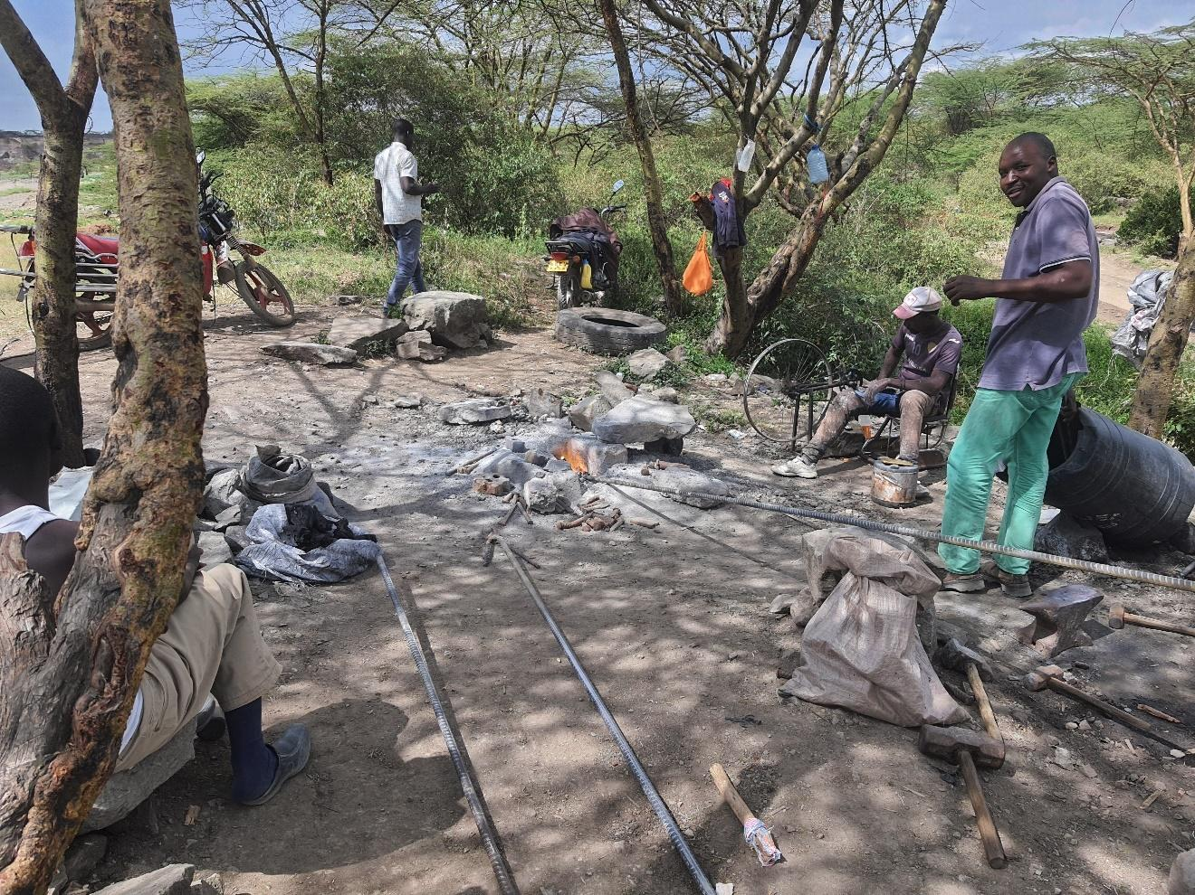Economic activity around quarry sites
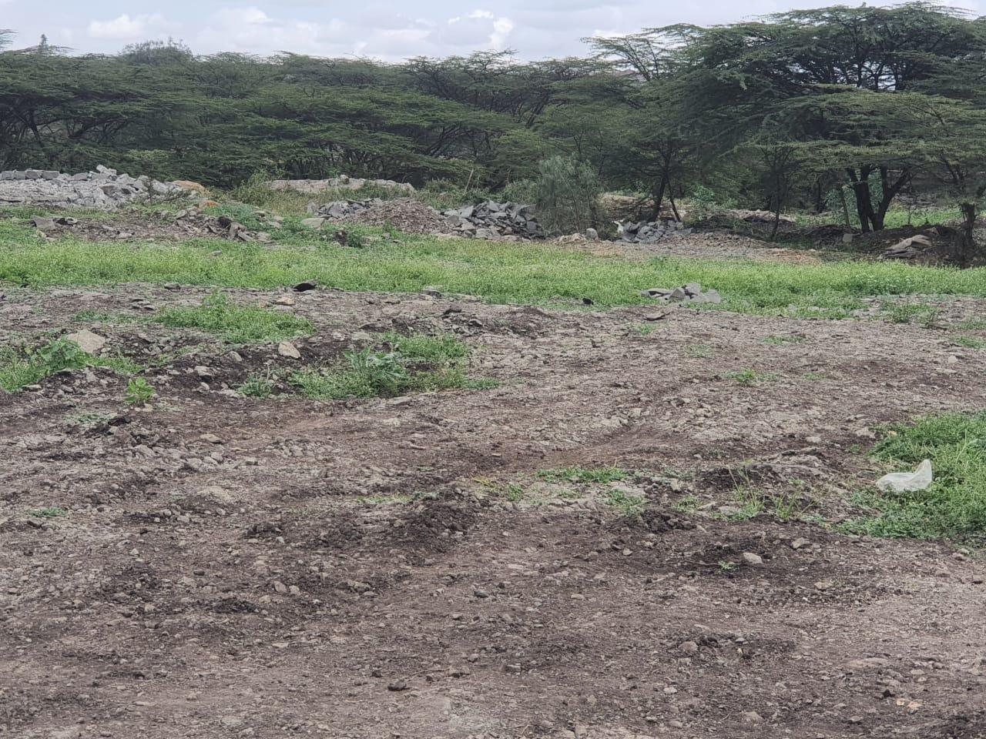Partial quarry rehabilitation 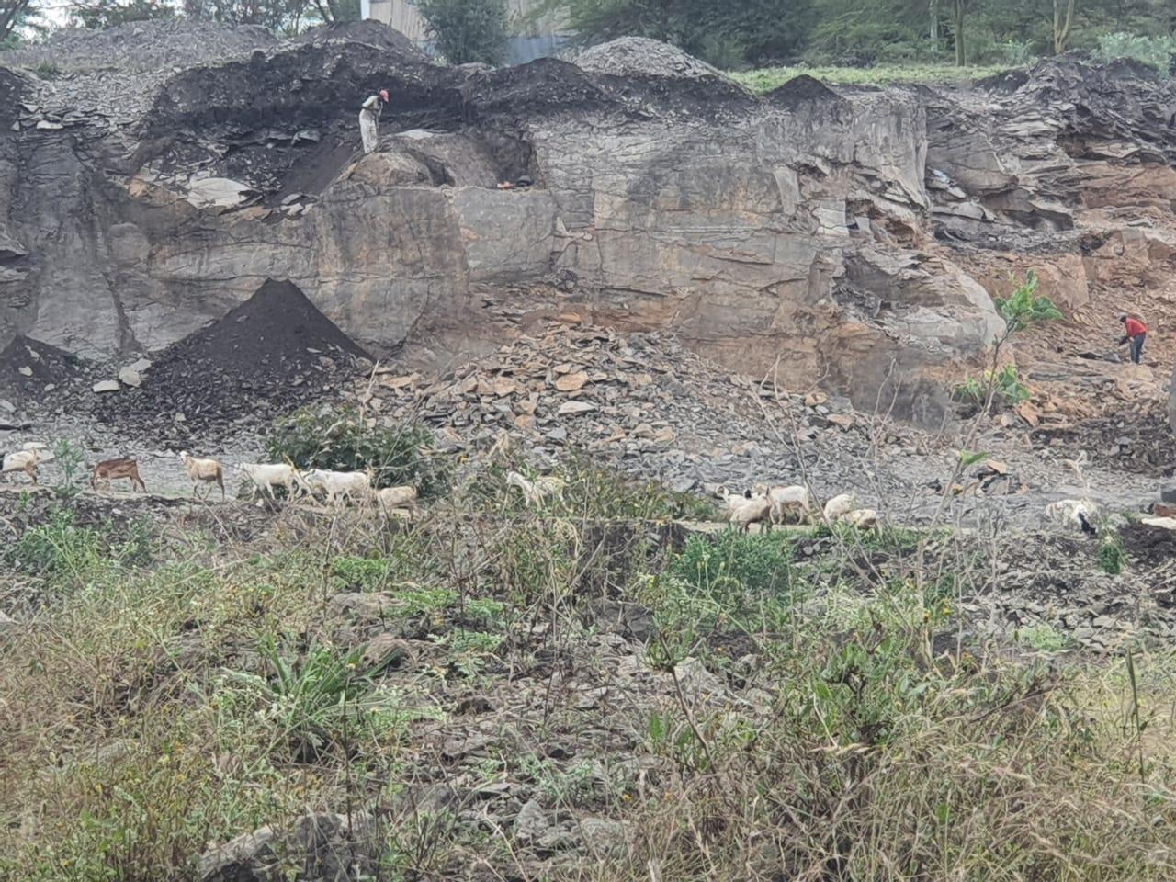Loss of pasture caused by quarying.
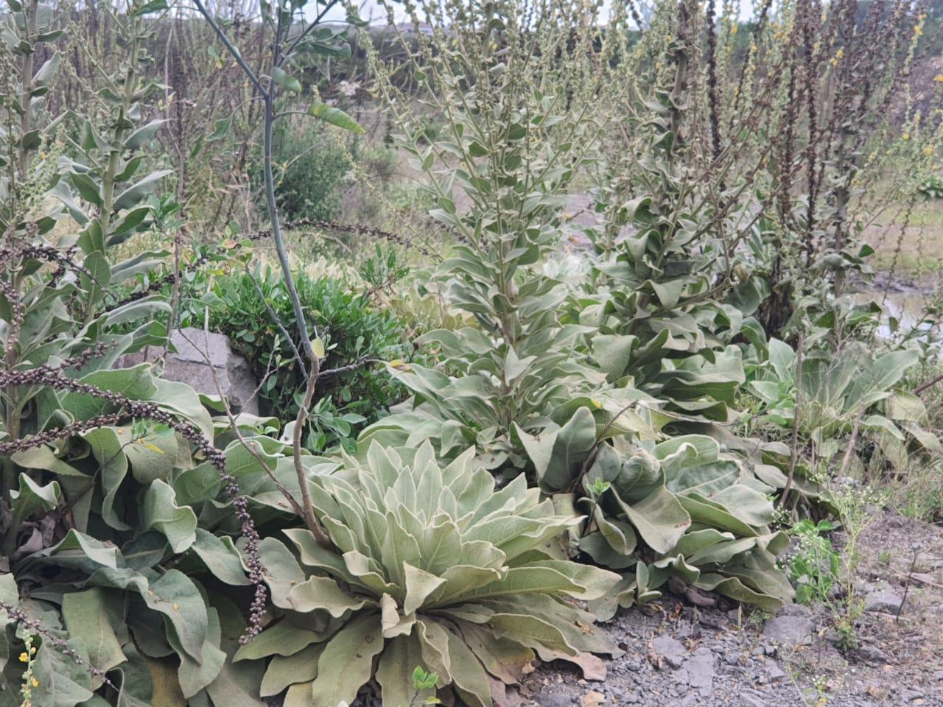nvasive species on abandoned sites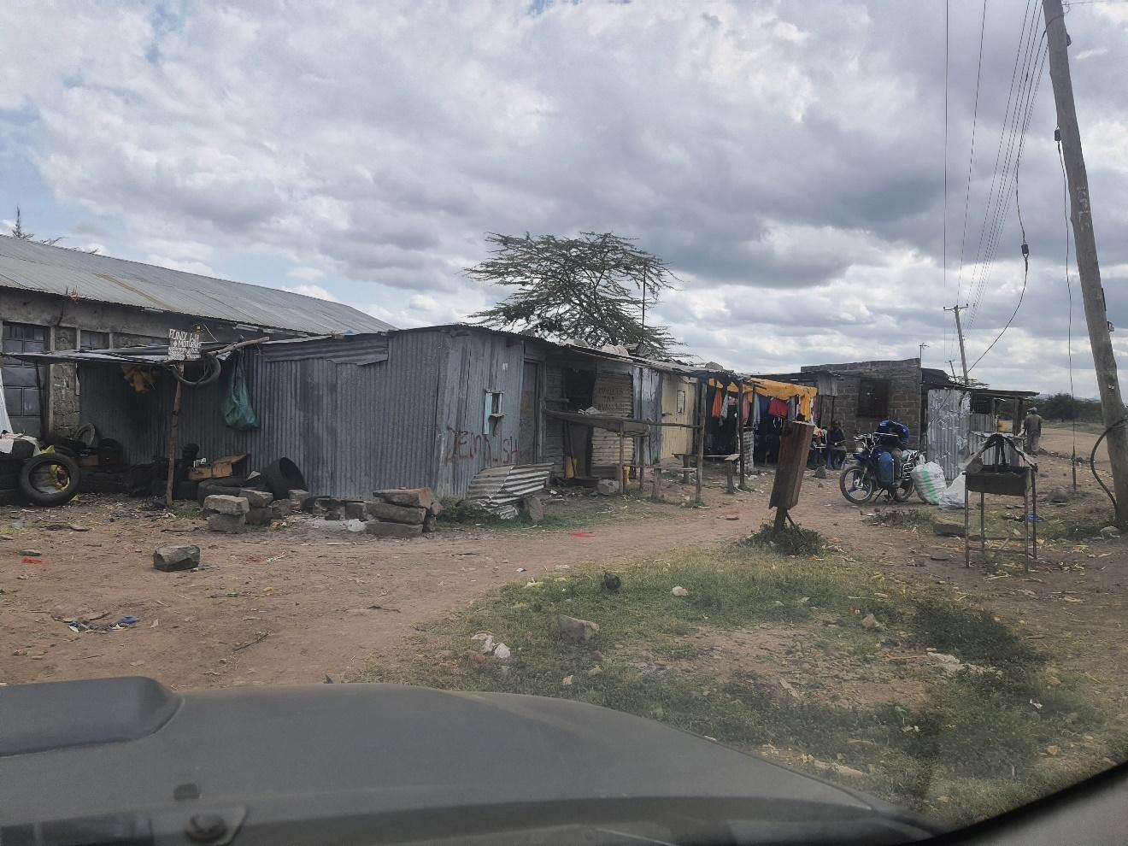Commercial activities within the quarry area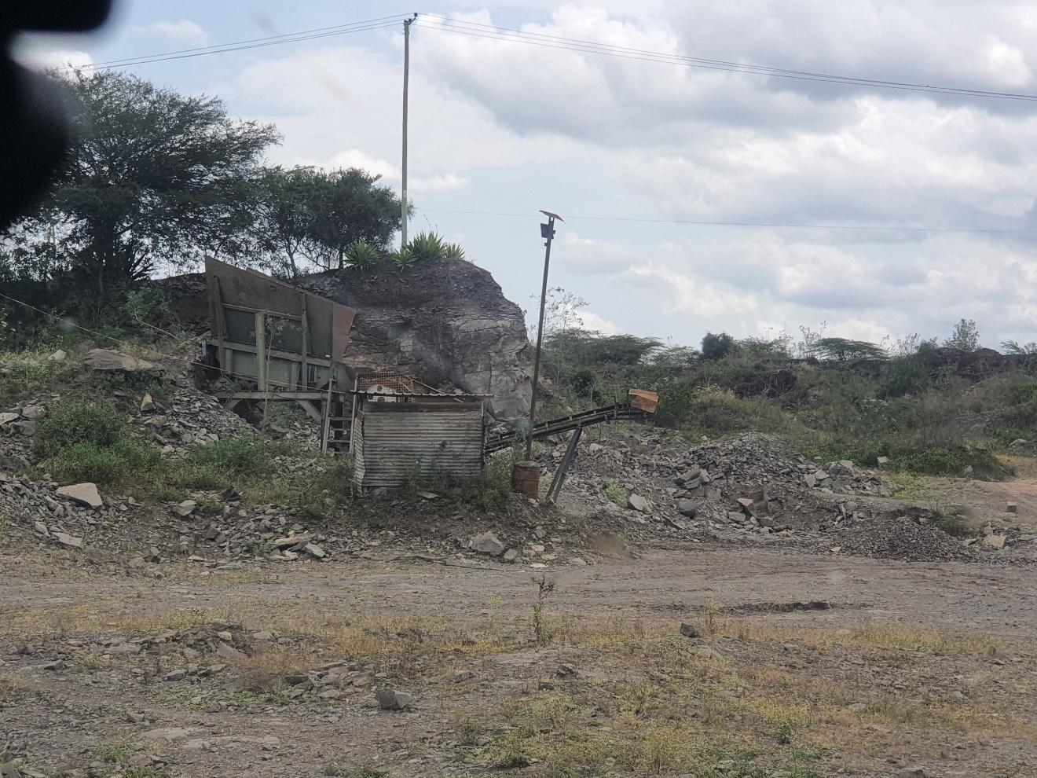
Abandoned quarry

